North Yorkshire and York Remote assessment of Covid-19
Version 9 Date 8/4/2020 (revision since last version in RED)
See advice on how to establish a remote ‘total triage’ model in general practice using online consultations
In the absence of national guidance please follow the steps below as a minimum (the steps correspond to the sections in this document)
- Follow BMJ guide for an overview (more detail here https://www.bmj.com/content/368/bmj.m1182)
- Use North Yorkshire and York assessment and management pathway (updated using RCGP and NICE guidance on managing community pneumonia)
- Asessing breathlessness DO NOT USE THE ROTH SCORE – use 7 key questions for assessing breathlessness from oxford covid unit
- Risk stratify using NEWS2 scoring and clinical judgment
- Use NICE traffic light guide to assess children as respiratory symptoms appear to be less prominent in children
- Use safety netting questions from RCGP
- Summary of NICE guidance “COVID-19 rapid guideline: managing suspected or confirmed pneumonia in adults in the community” to aid clinical decision making

- BMJ remote consultation guide (check for updates here)
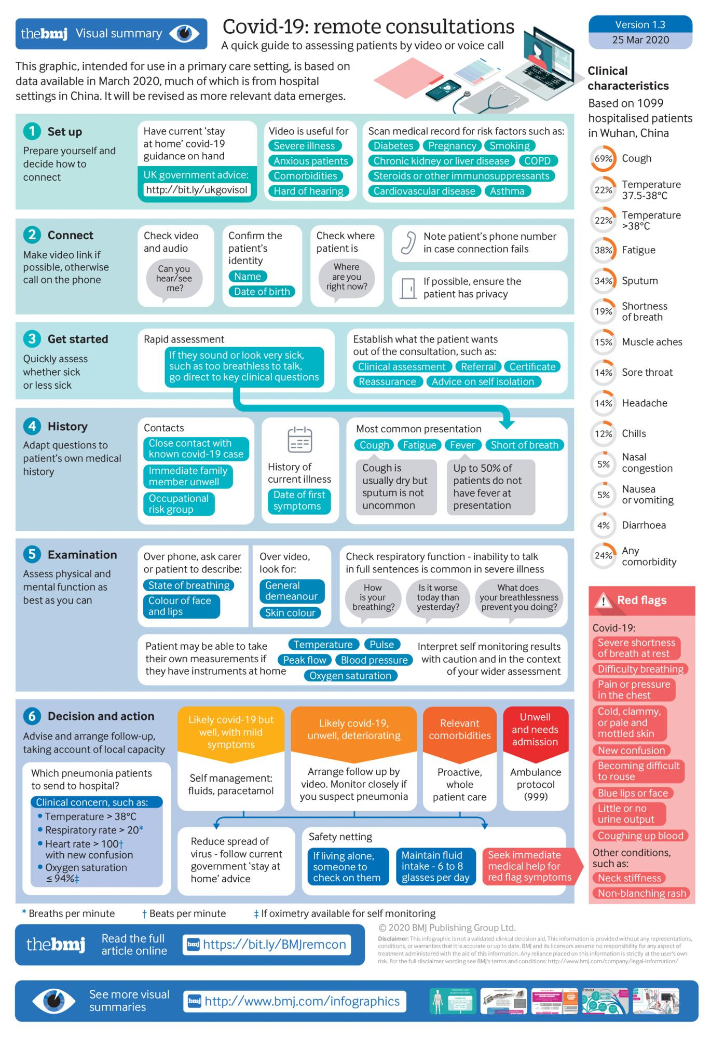
- Assessment and management pathway
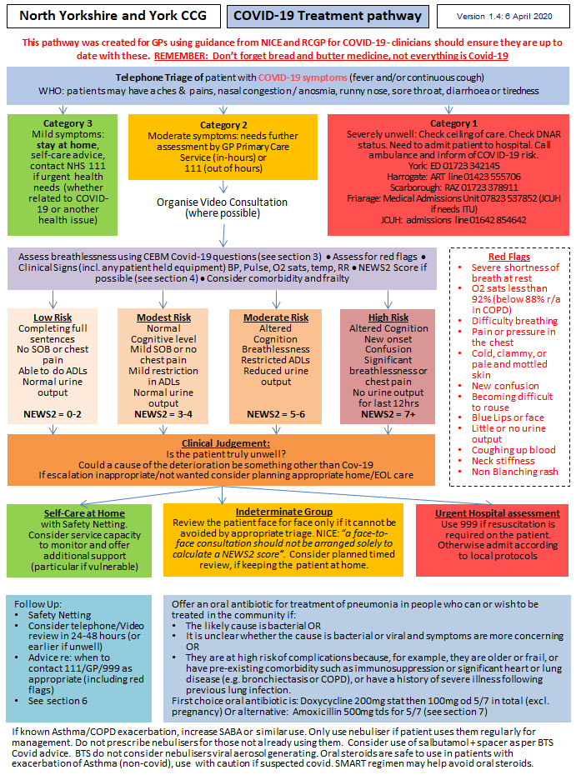
Link to BTS guidance for treatment of asthma patients
- Assessing breathlessness DO NOT USE THE ROTH SCORE – SEE 7 KEY QUESTIONS BELOW - Updated 2/4/2020
https://www.cebm.net/covid-19/are-there-any-evidence-based-ways-of-assessing-dyspnoea-breathlessness-by-telephone-or-video/

- Ask the patient to describe the problem with their breathing in their own words, and assess the ease and comfort of their speech. Ask open-ended questions and listen to whether the patient can complete their sentences.
“How is your breathing today?”
- Align with NHS111 symptom checker, which asks three questions (developed through user testing but not evaluated in formal research):
“Are you so breathless that you are unable to speak more than a few words?”
“Are you breathing harder or faster than usual when doing nothing at all?”
“Are you so ill that you’ve stopped doing all of your usual daily activities?”
- Focus on change. A clear story of deterioration is more important than whether the patient currently feels short of breath. Ask questions like
“Is your breathing faster, slower or the same as normal?”
“What could you do yesterday that you can’t do today?”
“What makes you breathless now that didn’t make you breathless yesterday?”
- Interpret the breathlessness in the context of the wider history and physical signs. For example, a new, audible wheeze and a verbal report of blueness of the lips in a breathless patient are concerning.

- Risk stratify using NEWS 2 score if possible
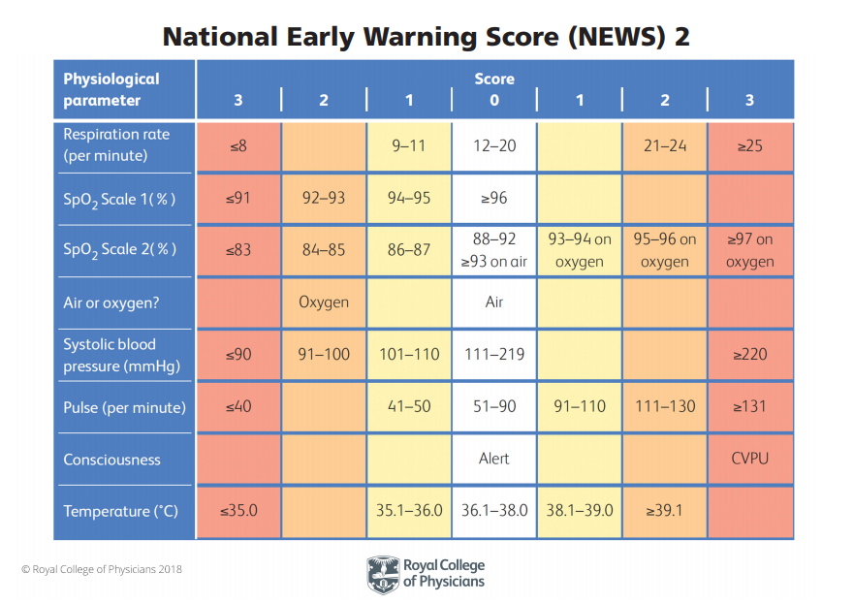
NEWS2 has been temporarily endorsed by the RCGP for use by GPs as part of a system wide response to COVID-19
Further learning resources on NEWS2 available on RCGP Hub

- For children, continue to use NICE traffic light system. Remember non-covid diagnoses
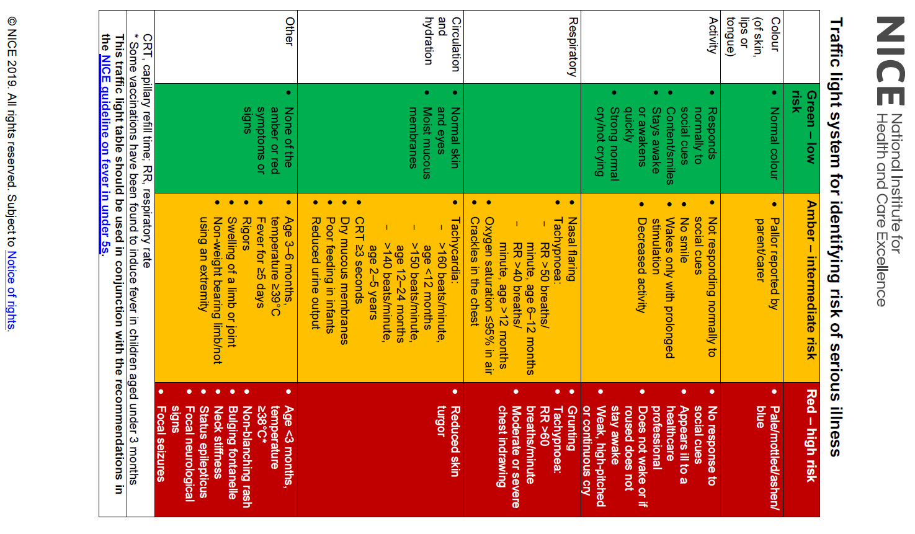
- Safety netting
COVID-19 Safety Netting Advice
Let me tell you what signs to look out for, that might indicate things were getting worse. If you start to:
- become significantly breathless,
- or develop pains in your chest,
- or become pale and clammy ‘like someone who is about to vomit”,
- or seem muddled or confused
then you should seek urgent medical advice.
Advice from RCGP COVID-19 Evidence Summary Clinical Management

- Summary of NICE guidance “COVID-19 rapid guideline: managing suspected or confirmed pneumonia in adults in the community” to aid clinical decision making
Differentiating viral COVID-19 pneumonia from bacterial pneumonia
It is difficult to determine whether pneumonia has a COVID‑19 viral cause or a bacterial cause (either primary or secondary to COVID‑19) in primary care, particularly during remote consultations. However, as COVID‑19 becomes more prevalent in the community, patients presenting with pneumonia symptoms are more likely to have a COVID‑19 viral pneumonia than a community-acquired bacterial pneumonia.

COVID‑19 viral pneumonia may be more likely if the patient:
- presents with a history of typical COVID‑19 symptoms for about a week
- has severe muscle pain (myalgia)
- has loss of sense of smell (anosmia)
- is breathless but has no pleuritic pain
- has a history of exposure to known or suspected COVID‑19, such as a household or workplace contact.

A bacterial cause of pneumonia may be more likely if the patient:
- becomes rapidly unwell after only a few days of symptoms
- does not have a history of typical COVID‑19 symptoms
- has pleuritic pain
- has purulent sputum.

Deciding about hospital admission
Be aware that older people, or those with comorbidities, frailty, impaired immunity or a reduced ability to cough and clear secretions, are more likely to develop severe pneumonia. Because this can lead to respiratory failure and death, hospital admission would have been the usual recommendation for these people before the COVID‑19 pandemic.

When making decisions about hospital admission, take into account:
- the severity of the pneumonia, including symptoms and signs of more severe illness (see recommendation 3.4)
- the benefits, risks and disadvantages of hospital admission
- the care that can be offered in hospital compared with at home
- the patient's wishes and care plans (see the section on treatment and care planning)
- service delivery issues and local NHS resources during the COVID‑19 pandemic.

Explain that:
- the benefits of hospital admission include improved diagnostic tests (chest X-ray, microbiological tests and blood tests) and respiratory support
- the risks and disadvantages of hospital admission include spreading or catching COVID‑19 and loss of contact with families.

Managing breathlessness
Be aware that severe breathlessness often causes anxiety, which can then increase breathlessness further.

Antibiotic treatment
As COVID‑19 pneumonia is caused by a virus, antibiotics are ineffective.
Do not offer an antibiotic for treatment or prevention of pneumonia if:
- COVID‑19 is likely to be the cause and
- symptoms are mild.

Inappropriate antibiotic use may reduce availability if used indiscriminately, and broad-spectrum antibiotics in particular may lead to Clostridioides difficile infection and antimicrobial resistance.

Offer an oral antibiotic for treatment of pneumonia in people who can or wish to be treated in the community if:
- the likely cause is bacterial or
- it is unclear whether the cause is bacterial or viral and symptoms are more concerning or
- they are at high risk of complications because, for example, they are older or frail, or have a pre-existing comorbidity such as immunosuppression or significant heart or lung disease (for example bronchiectasis or COPD), or have a history of severe illness following previous lung infection.

When starting antibiotic treatment, the first-choice oral antibiotic is:
- doxycycline 200 mg on the first day, then 100 mg once a day for 5 days in total (not in pregnancy)
- alternative: amoxicillin 500 mg 3 times a day for 5 days.

Do not routinely use dual antibiotics.

For choice of antibiotics in penicillin allergy, pregnancy and more severe disease, or if atypical pathogens are likely, see the recommendations on choice of antibiotic in the NICE antimicrobial prescribing guideline on community-acquired pneumonia.

Start antibiotic treatment as soon as possible, taking into account any different methods needed to deliver medicines to patients during the COVID‑19 pandemic.

Oral corticosteroids
Do not routinely offer a corticosteroid unless the patient has other conditions for which these are indicated, such as asthma or COPD.

