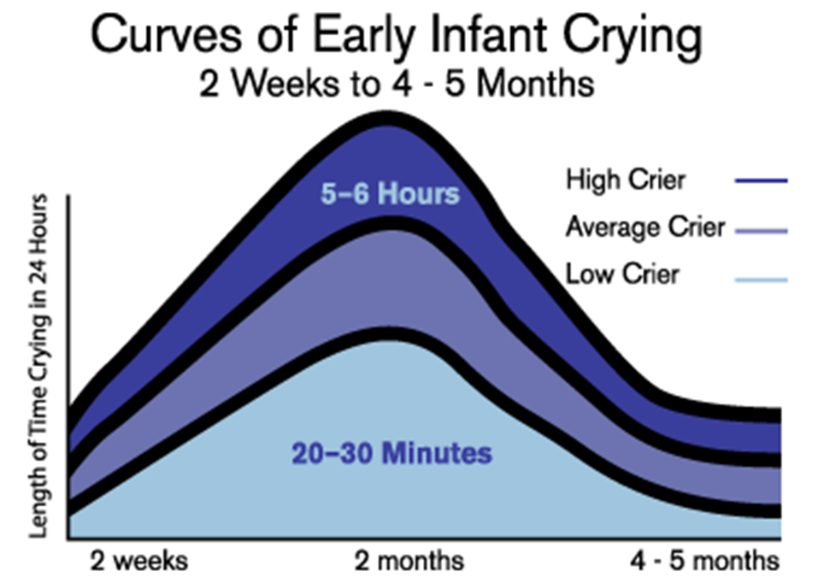

Barr R.G. *the normal crying curve; what do we really know?* Developmental Medicine and Child Neurology, 1990; 32(4): 356-362

Barr R.G. *the normal crying curve; what do we really know?* Developmental Medicine and Child Neurology, 1990; 32(4): 356-362