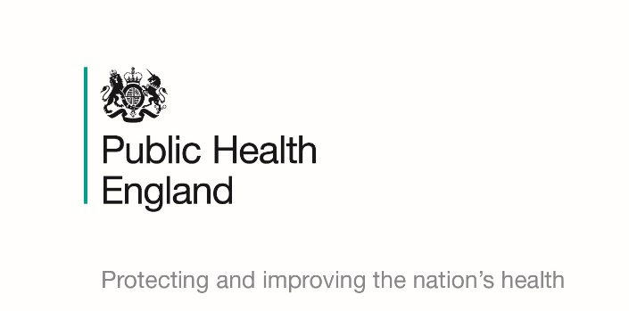

**Flu jab awards scheme**

**Get recognised for having your free flu jab to help protect vulnerable patients in your care**

Following on from the success of last year, NHS England and NHS Improvement and Public Health England have re-launched an awards scheme to recognise the efforts made by care sector organisations, who have achieved a high level of flu vaccine uptake.

**All frontline health and social care workers should have the flu vaccine to protect people they care for, who may not make a good immune response to their own flu vaccine.**

**What you need to do**

**To get the vaccine** - Take some identification that includes your name and the name of your employing organisation to a participating pharmacy that is offering the NHS flu vaccination service, or you can ask your registered GP if they are signed up to the scheme. Your ID could be an ID badge, a letter from your employer or a recent pay slip.

**To be awarded -** Depending on the percentage of staff who have received the flu vaccine before **31 March 2020**, certificates will be presented to your organisation based upon the following uptake:

* 70% of staff or above - gold accreditation
* 60-69% of staff - silver accreditation
* 50-59% of staff - bronze accreditation

**Make your appointment today and encourage colleagues to do the same, see if you can beat other care sector organisations in your area!**

