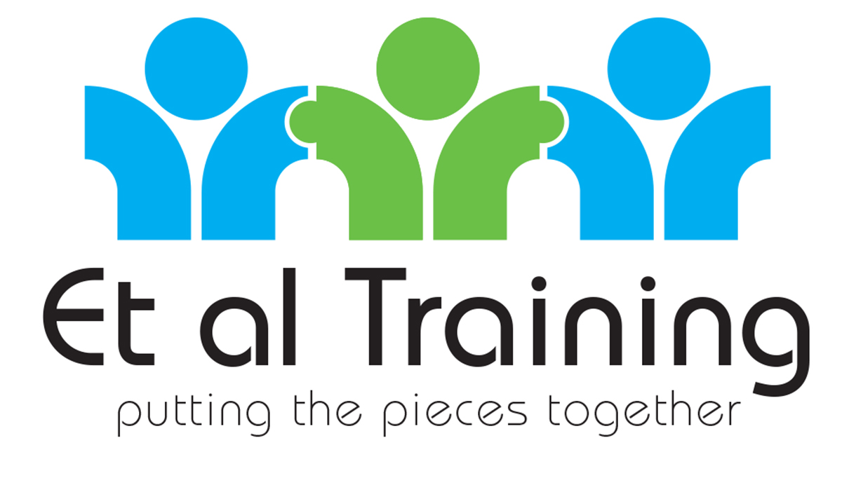

**Motivational Interviewing**

**Online – Live and Interactive Study day**

**9am to 4pm**

**Friday 13th November and Tuesday 8th December 2020**

www.etaltraining.co.uk

|  |  |  |  |  |  |  |  |  |  |  |  |  |  |  |  |  |  |  |  |  |  |  |  |  |  |  |  |  |  |  |
| --- | --- | --- | --- | --- | --- | --- | --- | --- | --- | --- | --- | --- | --- | --- | --- | --- | --- | --- | --- | --- | --- | --- | --- | --- | --- | --- | --- | --- | --- | --- |
| Is Motivational Interviewing for me? This interactive, lighthearted online, live study day is suitable for any and all members of the team. Registered delegates will receive their personal set of CRAFT cards, which are used during and then following the event, plus a responsibility reminder training aid! Delegates will interact, participate and influence the content of the day which will use bespoke situations to demonstrate the MI skills and they will not be asked to role play or listen to us reading through endless power point slides.  We all went into our roles to make a difference; we feel that we can make things ‘right’ for service users and their families and we spend much of our time trying to do so.  If you spend your life explaining what your service users should, could, must or need to do then this is the course for you. Motivational interviewing is a style of communication that uses a guiding/reflective style to engage with people, clarify their strengths and aspirations, and utilise their own motivations for change, and promote independence of decision making.  If this is sounding a little flowery, in a nutshell, MI saves your breath, your time and you are more effective when it comes to people making decisions about themselves. The feedback we regularly receive is that MI also helps to avoid burn out.  This course has run for several years and without exception evaluates as a stunning learning experience, where delegates leave knowing why they want to use MI, what MI is all about and have the ability to start practicing as soon as they finish the session.  What happens on the day?  We will use memorable explanations, demonstrations, interaction in pairs and most importantly relax and have fun. The extensive wardrobe and scenery available at our large training studio allows the tutors to create characters and situations to demonstrate the topics which are pertinent to our delegates. Face to face, and telephone consultation techniques will be included.  Though not listed below we will include many small breaks throughout the day to avoid screen fatigue   |  |  | | --- | --- | | 9:00 | Registration and Online access audio and visual confirmed | | 9:30 | Introductions – and online etiquette | | 9:30 | MI – What is it – why does it work – How the brain receives stuff! - Principles and Background in a nutshell | | 10:00 | The spirit & principles of MI | | 10:45 | Offering Advice – how to do this without pi**ing people off! | | 11:15 | Official Break | | 11:30 | When Ambivalence meets the Righting Reflex | | 12:00 | Change Talk– What is it? How can I find it? Why does it matter? | | 12:45 | LUNCH | | 13:30 | MI – Open questions, affirmations, reflections and summaries set in context and practiced | | 15:00 | Tea Break | | 15:15 | Putting it all together – demonstration designed by the delegates | | 15:45 | Questions and Evaluation | | 16:00 | Close | |  | Who is eligible to attend? Any Health Care Professional / member of your Primary Health Care team from the following CCGs: East Riding, Hull, North Lincs, North East Lincs, North Yorkshire, Vale of York How do I reserve a place? Follow either link to register for your preferred date:  13 November 2020  <https://www.eventbrite.co.uk/e/motivational-interviewing-for-primary-care-in-e-riding-lincs-hulln-yorks-tickets-126970322653>  8 December 2020  <https://www.eventbrite.co.uk/e/motivational-interviewing-for-primary-care-in-e-riding-hull-lincs-n-york-tickets-126983640487>  What’s the result?  This introduction to the principles, spirit and skills of motivational interviewing allows delegates the opportunity in a relaxed situation to have a go at the core MI skills before taking these skills into their workplace to practice. |