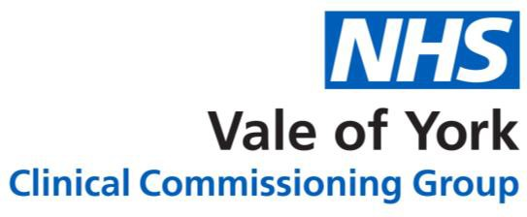

# Vale of York CCG – BCC Pathway Flowchart Pathway for Low Risk BCC

**Step 1**

GP identifies a Suspected Low Risk BCC *

* <1cm in diameter
* Below level of clavicle
* No other risk factors (as identified in [RSS guidance](https://www.valeofyorkccg.nhs.uk/rss/home/dermatology/))

Readcode suggested: Suspected skin malignancy

# Step 2

Refer to Minor Surgery accredited GP (**criteria defined)

* In-house
* or via Practice-to-Practice Referral Recommended timeframe for removal <8 weeks

# Step 3

Suspected BCC Removed if meeting the criteria for GP excision.

* + A *4mm excision margin* is recommended for all lesions - culminating in a 95% clearance rate.

Lesion sent for histology stating suspected BCC with 4mm excision margin.

# Step 4

Minor Operative GP to action histology and inform patient of the result (and referring GP if from another practice)

Log to be kept for submission for governance: 3 Categories:

|  |  |  |
| --- | --- | --- |
| Not a BCC/Non-malignant | Completely excised BCC | Incomplete excision/other malignancy |

# Step 5

Minor Surgeons to submit details of these 3 categories for audit purposes to CCG (initially data will be requested at 3m and thereafter 6 monthly) and engage in the national RCGP audit for minor operations gathering information about community management of BCC.

**Please note** that if any clinical concern about complexity of lesion or lack of availability of Minor Operation slot exists - then the clinician should refer to the local MDT for excision.

# Pathway for High Risk BCC

* Once identified - refer to local MDT as a suspected BCC
  + Above clavicle - Refer to Head and Neck
  + Around the eye - Refer to Oculo-plastic clinic
  + Anywhere else on the body - Refer to Dermatology/ Plastic Surgery MDT.

# *NICE Definition of low-risk nodular BCCs

That may be excised by GPs within the framework of the DES and LES under General or Personal Medical Services.

# **Vale of York Accredited GP Minor Surgeon

Previously, a register was kept of all GP minor surgeons. Now the decision to perform minor surgery and maintain skills are left to the individual GP to declare. Minimum standards include:

* Attendance on an accredited GP minor surgery course with supervised procedures until competence attained.
* Regular minor surgery sessions: to include 20 procedures/ year to maintain skills.
* Audit of minor operations in keeping with good medical practice.
* All GP minor surgeons in Vale of York removing low risk BCCs are required to sign up to the national RCGP audit and local data collection.
* Recommended Primary Care Dermatology Society weblink for BCC recognition and treatment - for all minor surgeons to review for CPD:

# References

[NICE guidance allows GPs to provide more minor surgery May 2010](http://www.gponline.com/News/article/1005652/NICE-guidance-allows-GPs-provide-%20%20minorsurgery/)

[Minor surgery – RCGP view](http://www.rcgp.org.uk/clinical-and-research/a-to-z-clinical-resources/minor-%20%20surgery.aspx)

Owner: Dr Emma Broughton Published: July 2020

Review date: July 2022