**COVID-19 update**

**Information correct as of 4pm 23 June 2020**

**In this edition**

* Updates to the COVID-19 web page
* Shielding updates
* Access to mental health crisis services in Pocklington and Stamford Bridge

**Attachments**

* none

All information provided in the COVID-19 bulletin is hosted online at <https://www.valeofyorkccg.nhs.uk/rss/home/infections-and-microbiology/covid-19/>

**Updates to the COVID-19 web page**

National and regional updates

[Shielding Letter to Patients](https://www.valeofyorkccg.nhs.uk/seecmsfile/?id=4122&inline=1)

[Shielding Letter to NHS](https://www.valeofyorkccg.nhs.uk/seecmsfile/?id=4121&inline=1)

[Alcohol Hand Sanitiser - Vehicle Fires](https://www.valeofyorkccg.nhs.uk/seecmsfile/?id=4123&inline=1)

COVID-19 landing page

To help colleagues find information on the dedicated COVID-19 web page we have reformatted the layout. We hope it is helpful.

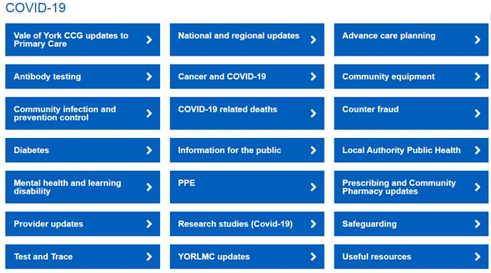

**Shielding updates**

The above links provide:

* A letter that shielded patients have / will receive from the Government from the 22 – 26 June.
* Letter to the NHS.  This states that *“the RCPCH expect that all patients who need to continue to shield will be seen in a specialist centre before September 2020 (but not all those with specialist appointments will need to shield). Decisions on shielding will generally be led by a specialist, balancing the clinical and social impact of shielding. Patients should only be removed from the Shielded Patient List by their GP or specialist following consultation with the child and their family, and other clinicians where appropriate.”* A decision tool to support conversations with patients is included.

**Access to mental health crisis services in Pocklington and Stamford Bridge**

Patients in the Pocklington and Stamford Bridge areas can access mental health crisis services by calling TEWV Freephone 0300 0200317 and selecting the York and Selby option.  Advice on what to do in a mental health emergency can also be found here [www.tewv.nhs.uk/crisisadvice](http://www.tewv.nhs.uk/crisisadvice)