**Wellbeing offers from City of York Council**

York Learning has just launched some free lunchtime wellbeing sessions aimed at those of us working probably from home at a desk (or dining or dressing table!) We’re putting on a variety of free tasters and some new short courses over the next few weeks and would love to welcome you along.

**Lunchtime Yoga for Wellbeing** is a great way to take a break from sitting at a desk and staring at a computer. Michelle our tutor will go through some basic stretches and routines, and share tips on posture and breathing. Choose from Monday or Wednesday lunchtimes (or do both!), starting 12.30pm, from Monday 8June.  Click [here](https://book.yorklearning.org.uk/Page/ProspectusList?search_DESCRIPTION_operator=Contains&search_DESCRIPTION_type=String&search_DESCRIPTION_value=wellbeing) to book

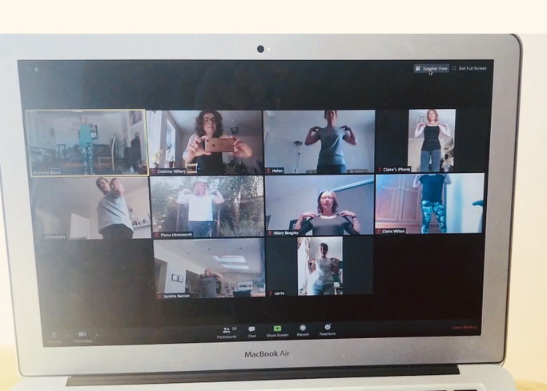

Here’s some of the York Learning team trying out the Yoga session last week.

*‘It’s great that Michelle was able to adapt to sitting at a desk or using the floor. I really liked that flexibility in the session.’* Carrie, York Learning

*‘I usually get up and stretch a few times during the day because I have back problems, but when there’s a tutor leading, I stretch a little bit further, hold poses for longer…The “discipline” makes a massive difference.’* Claire, York Learning

**Coming next week**

Our **Mindfulness Lunchtime Recharge** sessions starting on Thursday 11 June at 12.30pm will give you time and space to break away from the pressures of work and focus on the present moment, no previous experience necessary.  Further details [here](https://book.yorklearning.org.uk/Page/ProspectusList?search_TOPIC_operator=Equals&search_TOPIC_type=String&search_TOPIC_value=1.2C).

York Learning is also offering some creative options to help us with wellbeing.

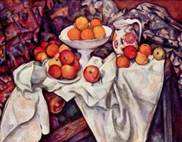 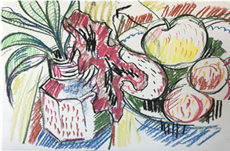 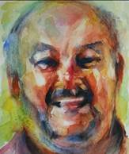 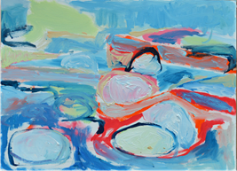

We have 4, brand new, free, Drawing and Painting workshops on our website, as of today!

The workshops will be led by two of our professional artists, Liz Foster and Sue Clayton.

There’s something here for everyone….2 whole hours of artistic freedom!

The first **Apples and Oranges** is this Friday, 5th June, 10am – 2pm. By the end of the session, you will have produced a Still Life painting of apples and oranges, using the work of Paul Cezanne as a starting point… beautifully simple and very rewarding!

**Still Life – Drawing:** - June 20th – Sat – 10am – 12pm, provides an introduction into a wide range of drawing methods. We’ll start by doing some very quick ‘warm-up’ drawing exercises, and then explore composition, line and tone whilst completing our Still Life.

**Expressive Watercolour Portraits**: - June 26th – Friday: - 10am - 2pm – learners will create a loose, colourful portrait using bold gestural brushstrokes in watercolour. We’ll explore techniques such as “Wet on Wet” and Colour lifting

**Sketching in Paint:** Thursday July 2nd 10am – 12pm: This painting workshop will help develop your confidence to sketch directly with paint (you don’t always have to draw first!) You’ll be encouraged to create more painterly and expressive, lose, work.

For further info or to book on any of the above art sessions click [here](https://book.yorklearning.org.uk/Page/ProspectusList?search_TOPIC_operator=Equals&search_TOPIC_type=String&search_TOPIC_value=9.2A).

If there’s nothing here that ‘floats your boat’ then take a look at what else we are offering for free – if it’s a health or fitness class that’s already started then click on the enquire button and we can send you details to join us!  Go to [www.yorklearning.org.uk/learning-for-everyone/](http://www.yorklearning.org.uk/learning-for-everyone/)   to take a look!

We will also shortly be launching our ‘Summer Festival’ so keep an eye on the [website](http://www.yorklearning.org.uk/) for further details – Keeping us busy and active over the summer holidays

If you would like further information about any of the above and would prefer to talk to someone then please email us at [York.learning@york.gov.uk](mailto:York.learning@york.gov.uk) with your contact number and we will get back to you.