pasted-image.tiff

**Easy Read**

**Going to the hospital because you are poorly with symptoms of**

**Coronavirus (COVID-19)**

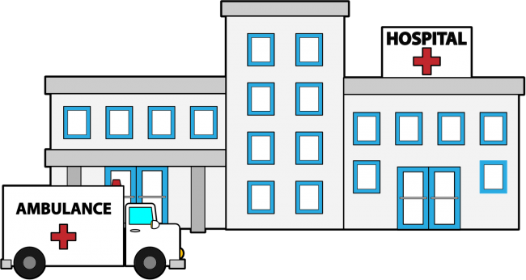

**If you need support with your admission, please contact the Learning Disability Liaison Nurse**

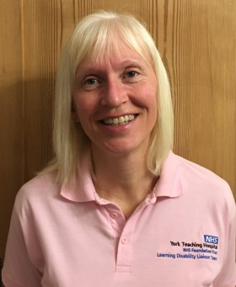

**Jo Blades 07795 126 473**



**Karen Pearce 07917 184 539**

|  |  |
| --- | --- |
|  | You have the symptoms of Coronavirus (COVID -19). |
|  | Follow the self-isolation guidelines,  (stay inside your home). |
|  | If your symptoms are getting worse and you feel really poorly ring **NHS 111** for advice. |
|  | If the person you speak to thinks that you need to go to hospital, they will call an ambulance. |
|  | The ambulance will come to your home.  A Paramedic will talk to you. |
|  | They will check your temperature and your breathing. |
|  | They may give you advice so that you can stay at home. |
|  | They may need to take you to the hospital in the ambulance. |
|  | If you have a carer or family member with you they can come to the hospital.  They may need to follow the ambulance in their own car. |
|  | Please take your hospital passport and medical information with you. |
| What happens in hospital when you have symptoms of Coronavirus Covid-19  **Easy read** |  |
|  | When you arrive at the hospital you will go to a special place. |
|  | The staff in the hospital will be wearing special clothes. |
|  | Your carer will talk to the staff about staying with you. |
|  | Your carer will need to wear the same special clothes. |
|  | The hospital staff will check your -  temperature,  blood pressure,  and oxygen levels. |
|  | They will also do a test to see if you have Coronavirus.  They will use a little stick with cotton wool on the end called a swab to do this test. |
|  | One will go inside your mouth to touch inside your cheek.  One will go up your nose. |
|  | We will know if you have coronavirus or not, the next day. |
|  | You may need an oxygen mask to help you breathe.  It will go over your nose and mouth.  Try to keep this on.  It will help you. |
| Q:\York Hospitals Trust\Directorate of Improvement\Safeguarding Adults\LEARNING DISABILITIES\CORONAVIRUS\CPAP mask.jpg | If you are very poorly you may need to wear a CPAP mask.  This looks a bit like a Darth Vader mask!  There may be other patients wearing them too. |
| Q:\York Hospitals Trust\Directorate of Improvement\Safeguarding Adults\LEARNING DISABILITIES\CORONAVIRUS\CPAP mask 2.jpg | The mask is attached to a machine.  It makes a noise.  It sounds like someone breathing loudly.  It may make a farting sound. |
|  | When the doctors and nurses are ready, you will go to the ward. |
|  | The nurses will come and say hello.  They will look after you. |
|  | Your carer can go with you to the ward.  They will still be wearing their special clothes |
|  | Your carer will be able to help you feel comfortable being on the ward.  They may not be able to stay with you. |
|  | The nurses and doctors will look after you.  They will help you get better. |
| Q:\York Hospitals Trust\Directorate of Improvement\Safeguarding Adults\SG Team specific\Team poster\Jo's photo - pink.jpg C:\Users\jblades\AppData\Local\Microsoft\Windows\Temporary Internet Files\Content.Word\Karen's photo - pink.jpg | Jo or Karen might not be able to visit you on the ward but we will keep in touch with the ward to see how you are doing. |

LD Covid-19 fact sheet - April 2020

Authors - Jo Blades and Karen Pearce - Learning Disability Liaison Nurse,

York Teaching Hospital NHS Foundation Trust

**Victoria Stenhouse** - **Symbolic Language Advisor**,

**Harrogate and District NHS Foundation Trust**, **Learning Disability Service.**

**Lynne Taylor -** Strategic Health Facilitation Lead & Recovery College

North Yorkshire Learning Disabilities, Tees Esk and Wear Valleys Foundation NHS Trust

Images by Easy on the i: [www.easyonthei-leeds.nhs.uk](http://www.easyonthei-leeds.nhs.uk) and The Picture Communication Symbols©1981-2020 by Mayer-Johnson LLC. All rights reserved worldwide. Used with permission.