PREGNANCY AND CORONAVIRUS: COMMUNICATION MATERIALS
We know that this is a particularly worrying time for pregnant women and the national NHS England Maternity Transformation Team has produced a range of communication products that can be used by local teams to help reassure women and provide them with the latest information. In addition, we are also producing a specific comms toolkit for pregnant women from Black, Asian, Minority Ethnic backgrounds, which will be available shortly.

AVAILABLE MATERIALS:
- Website: There is now a dedicated nhs.uk page: www.nhs.uk/pregnancy-and-coronavirus, which is regularly updated and has all the latest information about being pregnant during this coronavirus period. It also has links to helpful resources including a range of topical videos and leaflets and an animation (more details listed separately below). Please share with your patients and colleagues and make sure there is a link from your webpages.
- Leaflets: A series of NHS covid19 leaflets for pregnant women and new mums, which have been translated into 11x different languages and an ‘easy-read’ version (coming soon). Topics include:
- Looking after yourself and your baby during pregnancy
- Planning your birth
- Parent information for newborns
- Illness in newborn babies (especially looking out for the signs of Jaunice)
- Videos: In addition to the above leaflets, we have produced a series of videos with Baby Buddy and Best Beginnings to help remind pregnant women about some of the issues that they need to look out for when pregnant:
- Is my baby moving enough?
- Antenatal visits - what's the point?
- Antenatal visits - what can I do?
- Itching- what does it mean?
- My mental health matters
- Amination: Jacqueline Dunkley-Bent Chef Midwifery Officer for England and Matthew Jolly, National Clinical Director for Maternity, have produced this helpful animation which explains how NHS maternity services have changed during this time and why it's important to keep in touch with your maternity team.
- Article and Blog: We’ve prepared a template article that you can use for bulletins and web copy (ANNEX A) and have included a link to a recent blog by Jacqueline Dunkley-Bent Chief Midwifery Officer for England
- NHS ‘Help Us to Help You’ Campaign: NHSE has recently launched a national campaign to raise awareness that the NHS continues to be open for non-coronavirus medical issues and to encourage people to access these NHS services when they need to. Maternity services are one of the priority services that are being highlighted as part of this campaign. Specific posters and social media images have been designed and are now freely available from the PHE Central Resource Centre (see ANNEX B for some initial social media posting suggestions #HelpUsHelpYou #HelpUsHelpYouandYourBaby)
- Additional information for pregnant women about coronavirus and pregnancy is also available from the Royal College of Obstetricians and Gynecology and Royal College of Midwives

ANNEX A: ARTICLE [450 words] (can be used for bulletins and web copy etc):
Your Maternity Team is Here to Help You During Coronavirus

Recent data suggests that pregnant women are more anxious about their pregnancy and birth due to coronavirus, so it’s especially important to remember that your maternity team is here to help and support you during this uncertain time.

There's no evidence that pregnant women are more likely to get seriously ill from coronavirus. There's also no evidence that at coronavirus causes miscarriage or affects how your baby develops in pregnancy.

If you do get coronavirus symptoms then they are likely to be only mild or moderate, such as a cough or a high temperature, and the rate of contracting the virus is no higher than the general population, so please contact your midwife or maternity team who will advise you about what to do next.

If you have coronavirus symptoms when having your baby, then you will be cared for in a dedicated area in the maternity unit with a midwife. This is to keep you and everybody who uses or works in our services as safe as possible.

Midwives are working hard to make sure your maternity services continue to be personal and safe during this time. So, if you are pregnant it is important that you still attend your antenatal appointments and continue to seek advice from your midwife or maternity team.

If you need help with day-to-day things, you can also call the NHS Volunteer Responders on 0808 196 3646. They can help you with things like shopping, picking up prescriptions and taking you to appointments or the hospital.

Local teams are adjusting keep you and your baby safe during this time. Some appointments may now be made by telephone or by video call or via a local ‘pop-up’ maternity hub. You may need to give birth to your baby in a different place to where you had planned, and you may see staff wearing protective clothing.

Whatever the changes, it's really important that you have a midwife with you when you are giving birth to ensure you and your baby are safe. One birth partner is encouraged, so long as they do not have symptoms of coronavirus.

If you and your baby are well, you may be able to give birth at home, in a midwifery-led unit or in a birth centre. But if you've had any complications during your pregnancy you may be advised to give birth in a unit led by a doctor (obstetrician).

Keep up-to-date with all the latest coronavirus pregnancy and birth advice at www.nhs.uk/pregnancy-and-coronavirus, which also has links to helpful resources including a range of topical videos and leaflets and an animation. Alternatively contact NHS111 or in an emergency dial 999.

Good luck and don’t forget - your midwife and maternity team are always there to help you!

ANNEX B: suggested social media assets and copy
- Use as appropriate for Facebook, Twitter and Instagram
- See Help Us Help You Campaign folder for asset jpgs for Facebook, Twitter and Instagram postings
- All postings to include the hashtags: #HelpUsHelpYou #HelpUsHelpYouandYourBaby and a link to www.nhs.uk/pregnancy-and-coronavirus
THUMBNAIL ASSETS | POST COPY
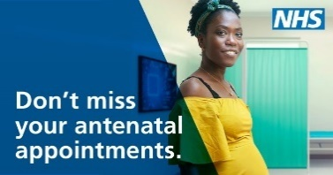 | If you are pregnant it is important that you still attend your antenatal appointments and continue to seek advice from your midwife or maternity team.  www.nhs.uk/pregnancy-and-coronavirus  #HelpUsHelpYou #HelpUsHelpYouandYourBaby
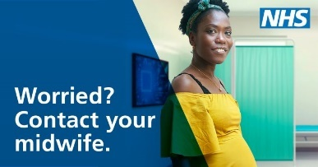 | If you’re worried about your health or the health of your unborn baby, please contact your midwife or maternity team. Get help early so you have the best chance of recovery.  www.nhs.uk/pregnancy-and-coronavirus  #HelpUsHelpYou #HelpUsHelpYouandYourBaby
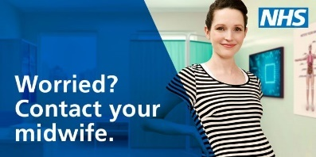 | Worried about coronavirus? Pregnant women are no more likely to get ill from coronavirus but if you’re worried about your health contact your midwife  www.nhs.uk/pregnancy-and-coronavirus  #HelpUsHelpYou #HelpUsHelpYouandYourBaby
If you're pregnant and need help with day to day things like shopping call the NHS Volunteer Responders on 0808 196 3646
They can help you with things like: shopping, picking up prescriptions and taking you to appointments or the hospital.
www.nhs.uk/pregnancy-and-coronavirus
#HelpUsHelpYou #HelpUsHelpYouandYourBaby

Keep up-to-date with all the latest coronavirus pregnancy and birth advice at www.nhs.uk/pregnancy-and-coronavirus, which has links to helpful resources; including a range of topical videos and leaflets and an animation
#HelpUsHelpYou #HelpUsHelpYouandYourBaby

