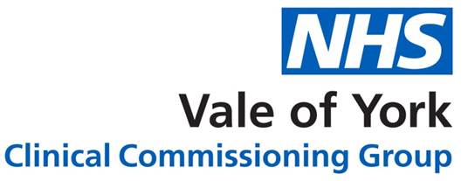

Correct as of 11 June 2020

Poster on freedom of choice (published by NHS)
Patients should be able to choose their own pharmacy, based on the convenience to them and the quality of service that is provided. A poster which sets out the right for patients to make their own choice has been produced and pharmacies are asked to display this prominently and as close as practicable to the location where patients receive prescriptions. Distance selling and internet pharmacies should display this information prominently on their websites and take reasonable steps to bring this notice to the attention of all patients, for example by including a copy of this notice with dispensed medicines that are delivered to patients.
In October 2015, NHS England wrote to all general practices and pharmacies to ask for their help in ensuring that all patients are aware of their right to choose freely without influence.
NHS England letter to pharmacies
The poster can be downloaded below and a copy has been sent to all pharmacies in the October edition of Community Pharmacy News which will arrive later during October 2015.
Poster on freedom of choice (pdf)

