Wellbeing Resources for Primary Care Staff in Vale of York
Introduction;
The COVID-19 pandemic has had a significant effect on health and social care services locally.
From a Primary Care perspective we have seen rapid change in the way services are being delivered and a huge effort to protect and proactively care for the most vulnerable in our community.
The sense is that the impact for primary care will continue beyond the initial acute phase of illness and will come in a number of waves highlighted by the following figure;
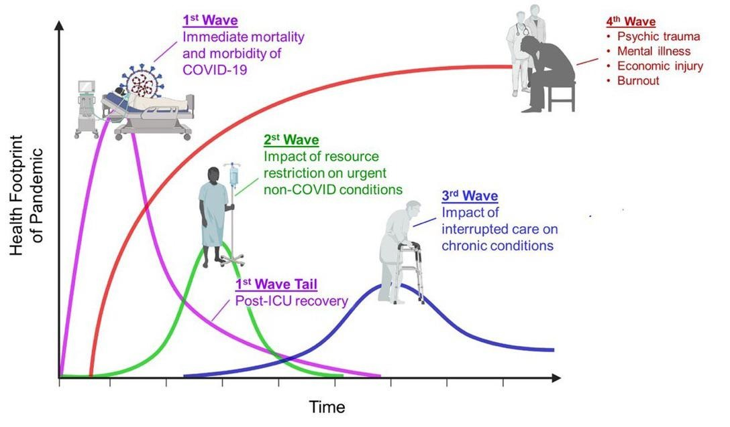
In order for those working in primary care to ensure they are able to work sustainably to meet these challenges a focus on wellbeing is essential. This focus can occur at multiple levels.

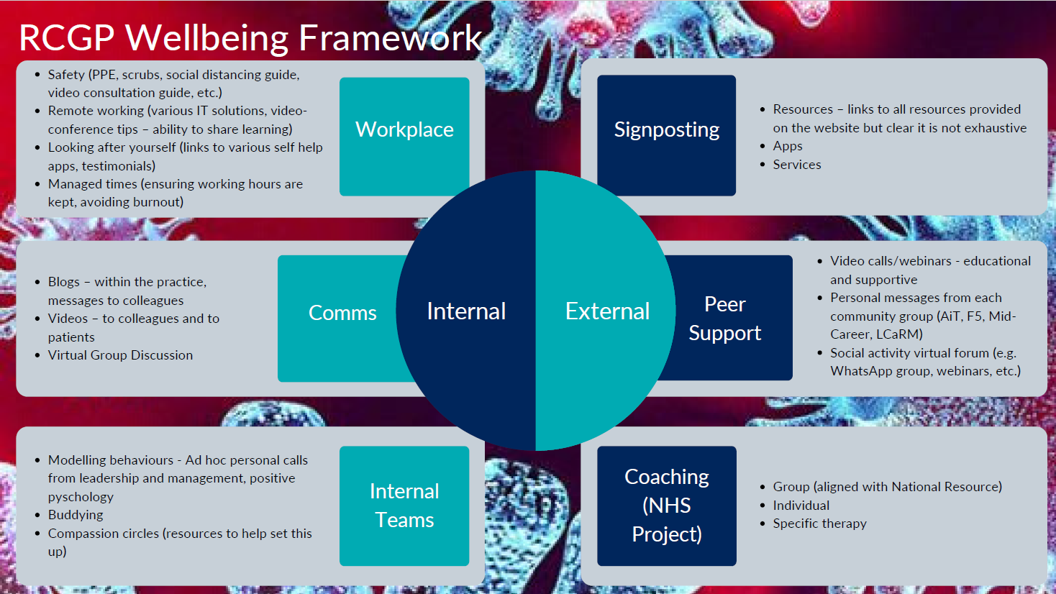

A number of resources are available to support a proactive stance to address our wellbeing.

National Resources
NHSE
www.people.nhs.uk – Gives an overview of what is available
www.peope.nhs.uk/help - Access to helplines for immediate support and free apps to help with many aspects of wellbeing – sleep, anxiety management, general wellbeing
https://people.nhs.uk/lookingafteryoutoo/ - a free individualised coaching service for everyone working in the delivery of primary care – clinical and non-clinical staff. General Practice, Dentistry, Community Pharmacy, Optometry. This is a fantastic resource – book via an online platform and receive up to four sessions of support.
RCGP
https://www.rcgp.org.uk/covid-19.aspx
Gives access to a resource hub and then the wellbeing section. Free access to everyone
BMA
https://www.bma.org.uk/advice-and-support/your-wellbeing
Free access to BMA resources – mainly focussed towards medical staff
RCN
https://www.rcn.org.uk/covid-19
See the ‘supporting you’ section
Academy of Royal Medical Colleges
https://www.aomrc.org.uk/covid-19-mentalwellbeing/
Focus on medical staff but access to a wide range of resources
Royal Pharmaceutical Society
https://www.rpharms.com/resources/pharmacy-guides/coronavirus-covid-19/coronavirus-wellbeing
Access to resources and a link to their Support Hub. Support mainly directed at Pharmacists
NHS Practitioner Health Programme
https://www.practitionerhealth.nhs.uk/covid-19-workforce-wellbeing
Local Resources
YORLMC
https://www.yorlmcltd.co.uk/wellbeing
Link to a suite of wellbeing resources that also links to a specific page for COVID 19

Further resources are being developed locally to focus on primary care staff to take part in group support sessions. This is based on something called the 20 minute care space and will be available soon more information will follow.

