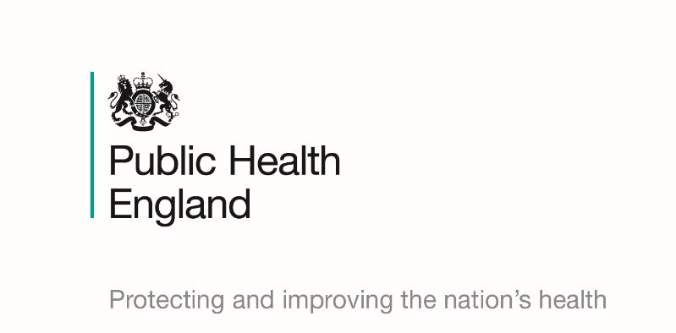
30 October 2019

Dear colleague
Recognition award for vaccination uptake amongst care sector staff across the North of England
You can help us to help you and the people you care for

In the North of England, NHS England and NHS Improvement and Public Health England have come together to set up an award scheme to recognise the efforts made by the care sector, care homes, hospices and domiciliary care providers, who have achieved a high level of flu vaccine uptake for their staff.

This scheme is being implemented following a successful pilot scheme that ran during the last flu season (2018-19).

The award includes all health and social care staff who are directly involved in the care of vulnerable patients/clients who are at increased risk from exposure to influenza. Vulnerable means those patients /clients in a clinical risk group for flu, or who are aged 65 years or over and is intended to complement any existing local initiatives.

The flu jab helps to protect you from catching flu and it also reduces the risk of you passing the virus on to the people you care for. There is an increased risk of them catching flu because of their long-term condition or disability, and they could develop complications and become seriously ill as a result.

Flu and its complications are one of the main reasons that people get admitted to hospital from the care sector, particularly during winter. Therefore, protecting individuals and populations through immunisation programmes is a highly successful public health intervention that saves many lives each year. Influenza kills an average of 8,000 people every year. If more of us get the jab, we are giving ourselves and those we care for, the best protection against an unpredictable virus.

All care staff who have direct contact with residents/clients/patients should have the flu vaccine to help protect vulnerable patients and clients, who may not make a good immune response to their own flu vaccine.

We urge employers to continue their efforts to protect their staff and most vulnerable patients/clients by encouraging care staff to be immunised. They can do this by accessing local schemes that are already in place or, if they are eligible as they are in one of the at-risk groups or other groups identified in the annual flu letter, by going to their own GP practice or any pharmacy. Details of these can be found at NHS Uk.

Qualifying Criteria

The award will be given based on the percentage of staff in receipt of a flu vaccine before the end of March 2020. Awards will be presented based upon an uptake as below:

- 70% of staff or above - Gold accreditation
- 60-69% of staff - Silver accreditation
- 50-59% of staff - Bronze accreditation

The process for submitting your application for your award:

As individual organisations will need to self-report your staff flu uptake levels to participate in the scheme, it is important that you capture the following information:

- Organisation name, address and contact details
- number of eligible staff
- number of staff vaccinated
- Percentage of staff vaccinated
- Type of care provider i.e. care home, hospice or domiciliary care
- CQC rating

Please submit the information requested in the six bullet points above via the following email addresses (please note that that there are different email addresses depending upon geographical areas across the North of England).
Applications must be submitted by 31 March 2020.

- Cheshire, Merseyside, Warrington & Wirral - england.pmonursing@nhs.net
- Cumbria and North East region - england.nursingandqualitycne.nhs.net
- Greater Manchester - england.jdflu@nhs.net
- Lancashire & South Cumbria - england.lancsnursingandquality@nhs.net
- Yorkshire and the Humber - ENGLAND.YandH-NursingReturns@nhs.net

Please note that all health and social care staff, wherever they receive their flu vaccine from can be counted in your return.

For further information please contact your respective independent care sector lead below:

- Cheshire, Merseyside, Warrington & Wirral: Suzanne Noon at suzanne.noon@nhs.net
- Cumbria and the North East: Ken Haggerty and Kathryn Dimmick at k.haggerty@nhs.net or k.dimmick@nhs.net
- Greater Manchester: Janine Dyson at janine.dyson@nhs.net
- Lancashire & South Cumbria: Annlouise Stephens at annlouisestephens@nhs.net
- Yorkshire and Humber: Gill Ramsden gil.ramsden@nhs.net

Please find attached a poster for you to display promoting the awards. Further resources for promoting flu vaccine take up amongst staff, including posters, can be found on the PHE campaign resource centre in the Help Us Help You campaign section: https://campaignresources.phe.gov.uk/resources/campaigns/92-health-and-social-care-workers-flu-immunisation-/overview

A useful leaflet for social care staff can also be found at: https://assets.publishing.service.gov.uk/government/uploads/system/uploads/attachment_data/file/824680/PHE_flu_immunisation_social_care_staff_leaflet.pdf

Yours Sincerely

Ruth Holt Ann Burrows
Director of Nursing Regional Lead for NHSE/I
Independent Care Sector Regional Lead PHE North Regional Team
NHSE/I

