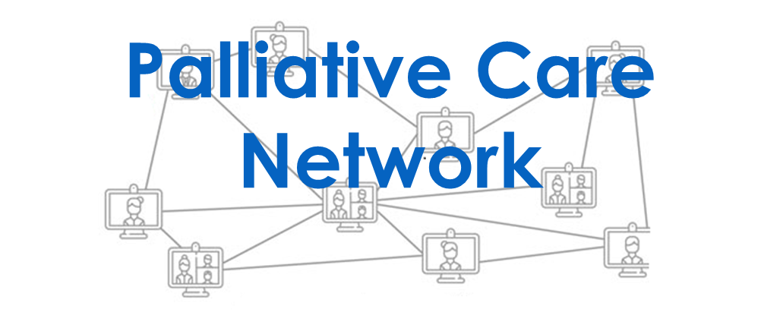
We would like to invite staff working in care services across the Vale of York to join our free Palliative care Network.

Delivered by specialist staff from across the sector:
- Community Nursing,
- St Leonards Hospice,
- Vale of York CCG and
- York District Hospital.

Taking place on Zoom, collaboration through ECHO will help us learn, teach and share experiences to enhance our Palliative Care skills.

1st session: 23rd February 2021at 2pm

Contact us at:
ProjectECHOTeam@stleonardshospice.nhs.uk

