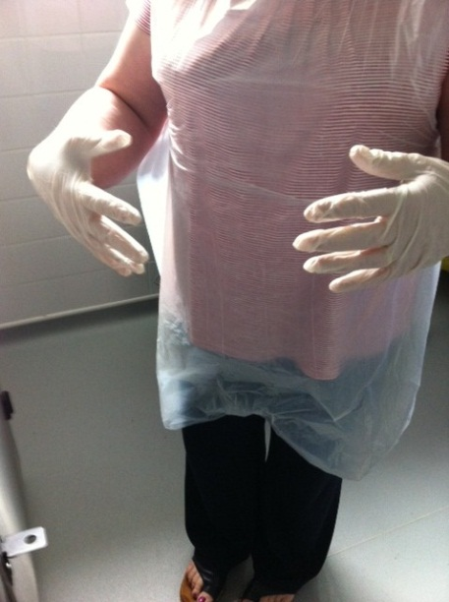

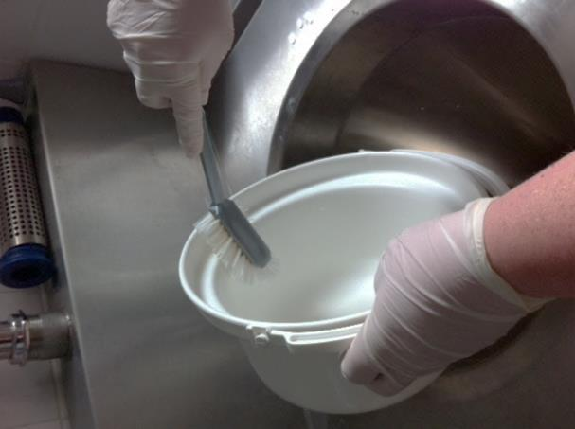
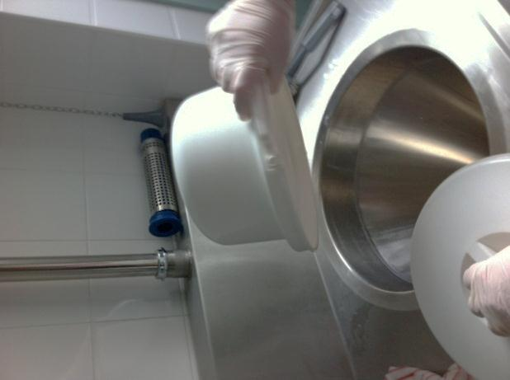

3. Remove debris with brush and empty
2. Empty dirty pot into slop hopper
1. Ensure appropriate PPE is worn.

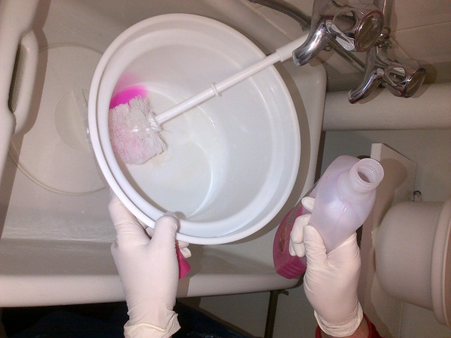
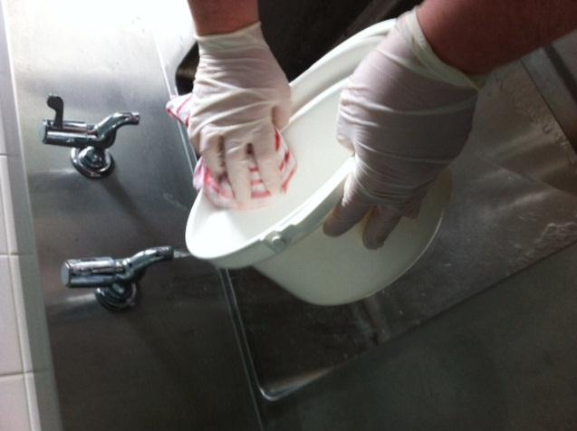
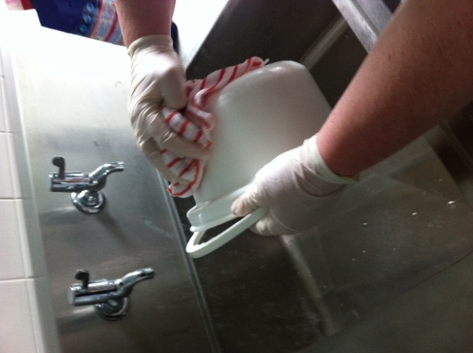

6.. Clean outside with Milton cloth
4. Clean pot and lid with detergent and warm water and rinse

5. Clean inside using Milton type solution (50ml- 1litre of water) with appropriate red cloth.

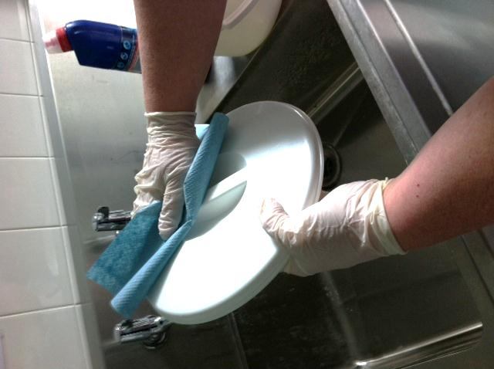
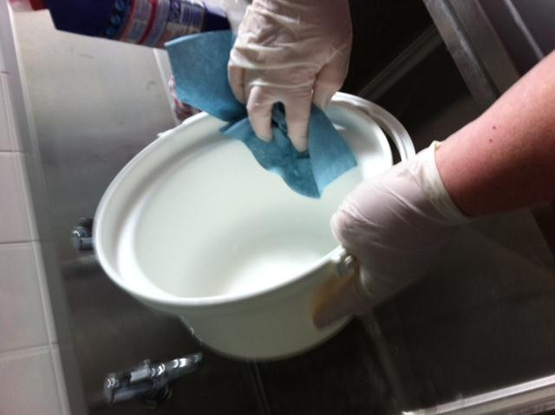
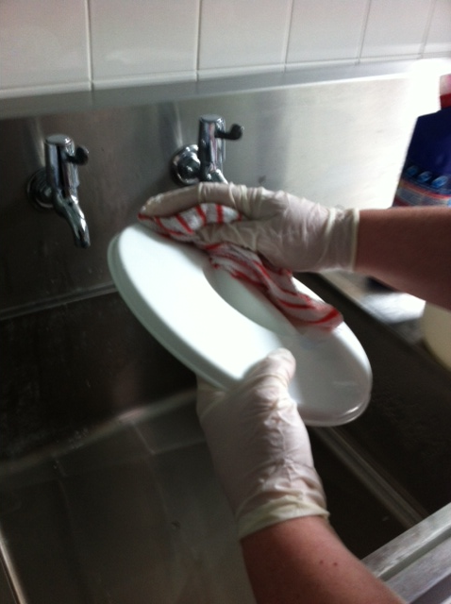

9.Wipe excess moisture off lid don’t leave it dripping wet!!

8. Dry excess moisture inside using a dry paper towel
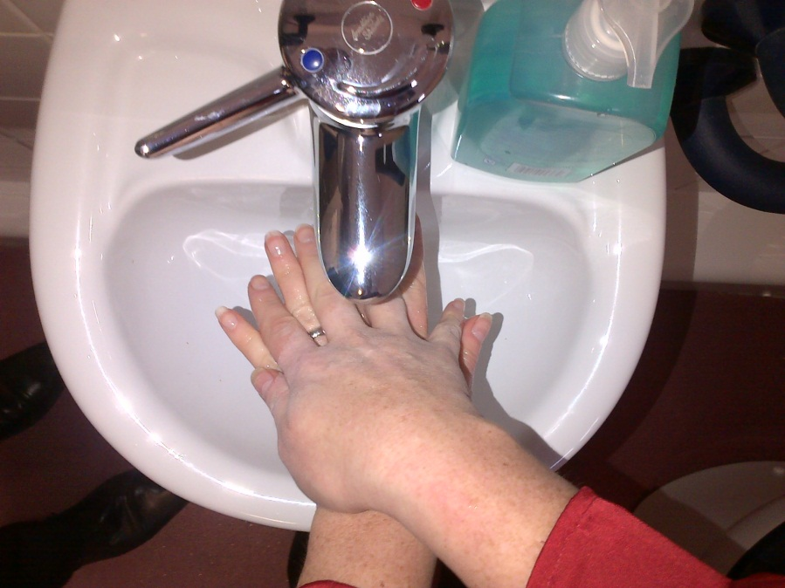
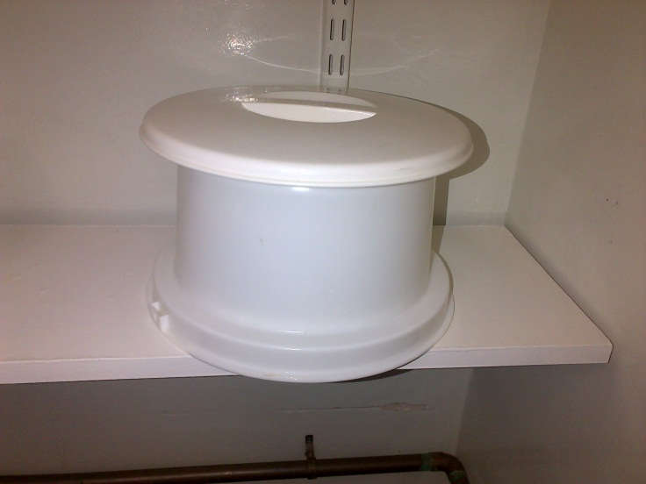
7. clean lid with the milton cloth
11. Remove PPE and
Wash hands!!
10. Check and store upside down with lid on top

For care homes that do not have a washer disinfector
Killing germs on a bed pan requires a 3 step process. Cleaning, disinfection and sterilisation.
Cleaning is the physical removal of body fluids and many germs, while it is an important part of the germ-killing process, it doesn’t kill germs by itself.
Disinfection is the removal or destruction of more germs and even though some disinfectants/detergents claim to kill most germs they won’t completely eradicate them.
Sterilisation is the complete destruction or removal of germs, for you to be able to totally remove germs your cleaning and disinfection process needs to be thorough. Sterilisation either happens with the use of hot temperatures eg disinfecting machines or by the use of a hypochlorite solution such as Milton - 50ml – 1 litre of water.
The above process should be followed. You should try to avoid splashing onto the clothing or exposed skin.
NB Milton should be made freshly each day as its effectiveness reduces after 24 hours.

The disposable cloths should be disposed of regularly.

You need to sterilise each pan even though you are using a disinfectant you generally won’t have enough time for the chemical to work effectively as some chemicals take up to 10 mins of contact time to do its job.
When using a washer disinfector you should clean off any debris before placing into the disinfector

All commode pots, bed pans, urine bottles must be checked and if they are scratched, stained, tainted or the handle is showing corrosion these must not be used and must be replaced with a new one.
Sluice and disinfector rooms must be regularly cleaned and sanitised all surface areas including shelving, walls and floors, using a chlorine based solution eg milton. This is to reduce the risk of contamination from all known infectious diseases eg norovirus

