Incident reporting and management system

NHS North Yorkshire CCG and NHS Vale of York CCG will moved to a new system for reporting and managing incidents. We are using a system provided by the NHS North of England Commissioning Support Unit.

The system uses the same software as we used previously although there will be some cosmetic differences. The new system is called Safeguard Incident and Risk Management System (SIRMS) which can be found here https://sirms.necsu.nhs.uk

You can log into the system with your new CCG username and password (i.e. the credentials that you use when you first log into your laptop or PC).

For any troubleshooting queries, please contact nyy.incidents@nhs.net

1. 1 How to login to SIRMS to report an incident
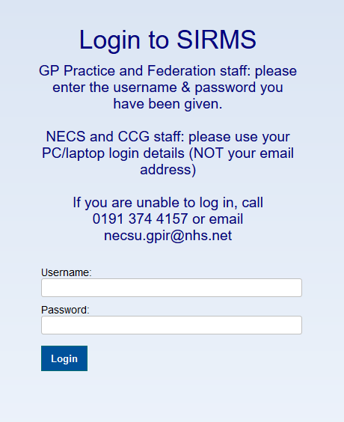 | SIRMS can be accessed via the following link: https://sirms.necsu.nhs.uk  Login to the SIRMS using your computer/windows login details
Once logged in select “CCG from Menu to take you to the incident form shown
Once logged in, select the North Yorkshire CCG and Vale of York CCG link.
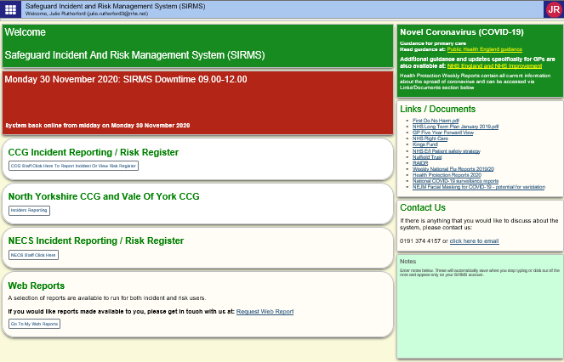
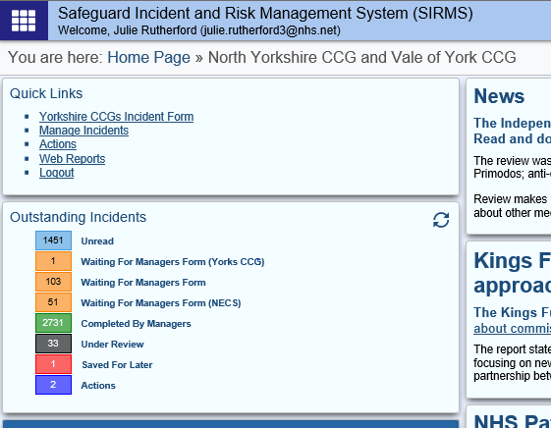 |  | You can access the CCG’s “Incident Form” you need to complete via this link
1.2. Filling in the incident Form on SIRMS
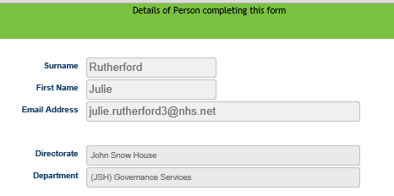 |  | The details of the person completing this form will be automatically populated and the orange highlighted fields are mandatory fields.  Primary cause groups are categories of incidents, choosing one of these primary cause groups from the drop down will affect the primary cause and secondary cause choices in the next fields.
1.3. What happened
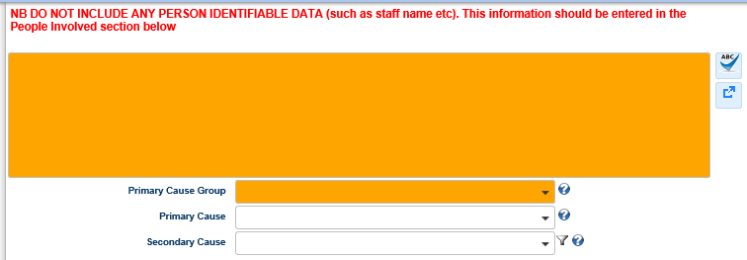 |  | What happened – please describe the incident but do not include any person identifiable data  Primary cause groups are categories of incidents, choosing one of these primary cause groups from the drop down will affect the primary cause and secondary cause choices in the next fields.
1.4. What did the incident involve
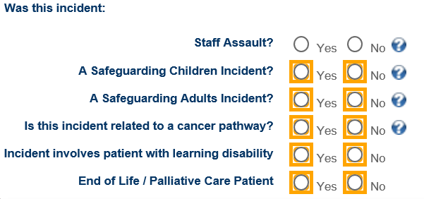 |  | Staff Assault  If a member of staff has been assaulted either physically or verbally please select “yes”. You may also have to make a further report to the NHS Security Management Service through the Physical Assault Reporting System (PARS)  Safeguarding Children and Adult incident  If you are logging a Safeguarding incident onto SIRMS, please be aware that this does not replace you legal duty to report this to the relevant authorities according to agreed processes.
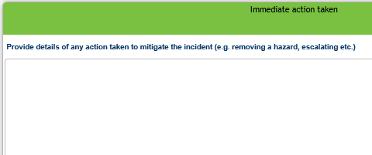 |  | Document any action taken to prevent the incident happening again
1.5. Where did the incident happen
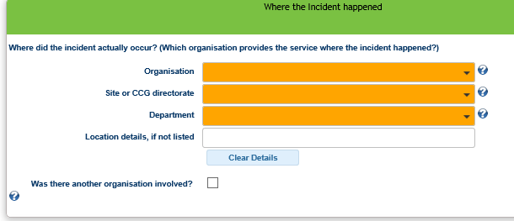 |  | Organisation  Where did the incident actually occur? E.g. where the patient discharged from or which organisation provides the service in which the issue has happened?  Site  Which site within the organisation did the incident occur? If a CCG, which directorate? If the site is not listed here for the organisation, please detail below in the ‘location details’ field  Department  Which department or service did the incident take place? The fields can be used to identify exactly where incidents are happening, which help to identify themes and trends and possible targets for CCG inspections. If the department you want to report against isn’t listed please detail it below in the free field text
1.6. Did this involve or include:
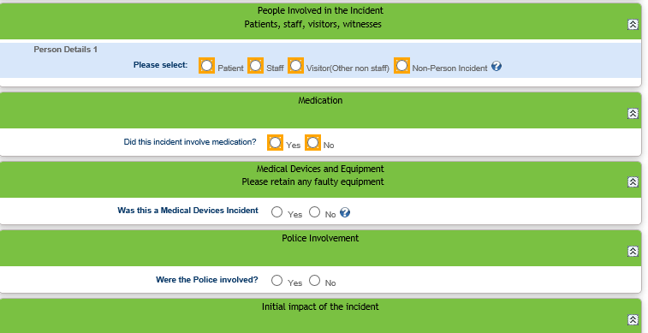 |  | Fill in details as appropriate:  If you wish to report an issue about a system which doesn’t necessarily involve an individual patient, staff member etc. please select ‘non person incident’ from the drop down menu  Medication does the incident involve medications – ‘Yes’ or ‘No’
1.7. Impact of the Incident
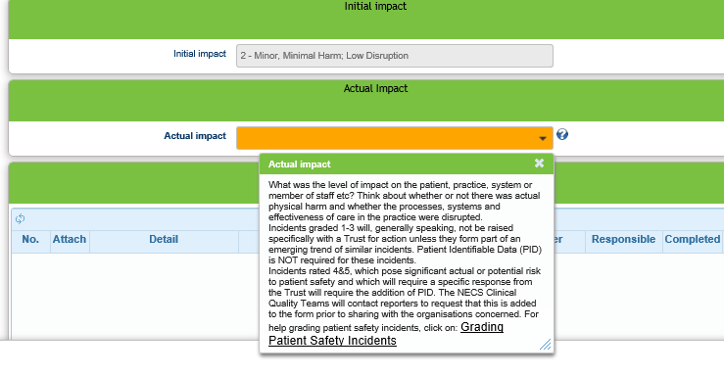 |  | Use the drop down field to determine the initial impact of the incident What impact did the incident have on either the person or people involved, delivery of service etc.?  - No harm negligible  - Minor minimal harm, low disruption  - Moderate short term harm of disruption  - Major, permanent, server disruption  - Catastrophic– death, service system failure  - Near miss  - Soft Intelligence  If you need further help on grading patient incidents you can click on the pop up text will give you access to the ‘Grading Patient Safety Incidents’ on the incident reporting web form.

1.8. Who to Notify
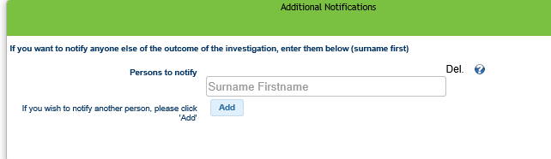 | Who to notify  In this section identify your line manager as they will need to be notified about this incident.  You can notify additional people of the incident if they are a user of SIRMS  Enter the surname and the system will search the user database – if the person is an active user their email will pop up.
1.9. Submit you incident
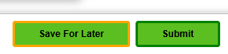 | If you are finished reporting your incident you can submit the incident.  If not you can submit your incident later if absolutely necessary, but we do not recommend you do this
Incident Submitted  AUTOMATIC EMAIL - DO NOT CLICK REPLY  Dear reporter  Thank you for using SIRMS to report this incident. Please see below for details of how this incident will be handled:  NECS and CCG reporters should contact the NECS governance team for details of what happens next, email: nyy.incidents@nhs.net | Once you have submitted your incident you will receive an email outlining how your incident will be handled

