
Safeguarding ….


These are key messages for Primary Care practitioners regarding children, young people and adults at risk of harm: December 2020
Primary Care Briefing regarding Young People and Drug Misuse (see below): signs to spot, services to support the young person/family and information on intelligence sharing.
City Of York: North Yorkshire:



City Of York: Healthy Child Service – Virtual Offer

From September 2020, the Healthy Child Service school nursing team (City of York) have been providing video consultations for appointments and ‘drop in’ sessions to pupils returning to school. Pupils can access this directly or can be signposted to the service by school staff.
Alongside this pilot there continues to be a text service to the school nursing team for use directly by pupils. The service is continuing to accept new referrals by professionals and parents.
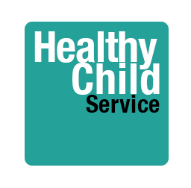

Contact details:
School nurse text number (for pupils only) 07833 437363
HCS-secure@york.gov.uk
Telephone number (for parents and professionals) 01904 555475
Safeguarding children and young people with LD and autism:
Some helpful guidance which was shared with us around the specific challenges facing children and young people with LD and autism. Directed particularly at primary care.
New MARAC Referral Form
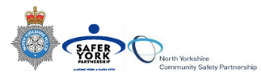
The MARAC Referral Form has been updated and is now available; see the form attached or follow the link: https://northyorkshire.police.uk/maracforms/
Wherever possible, the consent of the victim should be obtained prior to referring the case to MARAC and it is good practice to work in partnership with the victim where possible in order to obtain the most up-to-date information directly from them.

Where the victim does not consent to a referral and the case is deemed as being high risk, the case should be referred to MARAC as per Safelives guidance.
NYSCP has updated its Practice Guidance, One Minute Guide, Private Fostering: What you Need to Know video and webpage for professionals as well as created a new page specifically for parents. Links are as follows:
A private foster carer is someone other than a parent or a close relative who cares for a child for a period of 28 days or more, in agreement with the child’s parent. It applies only to children under 16 years, or under 18 if they are disabled.

Private Fostering and What You Need to Know video here
Practice Guidance here
Private Fostering One Minute Guide here
Private Fostering webpage for Professionals here
Private Fostering Webpage for parents/carers here

Useful guidance on the use of the Mental Capacity Act for decisions regarding clinical treatment and care: An introduction

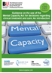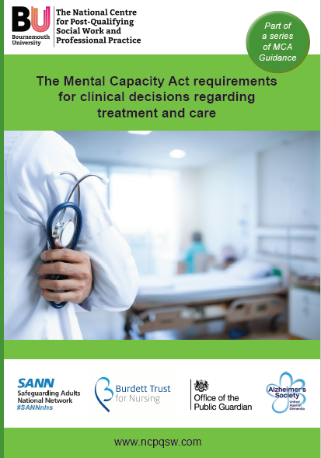
You can download the resources which accompany this booklet as part of the MCA series, at https://ncpqsw.com/downloads/

Information on the Perinatal Mental Health Service for North Yorkshire and York:
https://www.tewv.nhs.uk/services/north-yorkshire-and-york-perinatal-mental-health-service/


Wishing You all a Merry Christmas from the Primary Care Safeguarding Team


