An open letter to patients in the  Vale of York | West Offices  Station Rise  York, Y01 6GA  Y01 6GA  Tel: 01904 555870  RNID typetalk: prefix-18001  Email: valeofyork.contactus@nhs.net  Website: www.valeofyorkccg.nhs.uk
 | 25 March 2020

As a result of the current COVID-19 outbreak, primary care is facing unprecedented demands on its services. In addition, we are also facing substantial staffing shortages due to those needing to self-isolate in line with current guidance. We understand that many people will be feeling anxious and uncertain in these challenging times.

In response to the pressures across healthcare the way in which primary care operates is changing to enable us to continue to provide services where they are most needed. Practices will be working to minimise face-to-face contact with patients in order to:

- reduce the risk of transmission of coronavirus;
- to protect our most vulnerable patients and staff; and
- enable clinicians to continue to care for those patients who need it most.

The vast majority of consultations will now be done via phone, e-consultations or video consultation. Non-urgent work is being stopped or postponed until there is capacity to do so. Practices are working together as networks to manage this unprecedented demand.

Patients may find that they are assessed by a neighbouring practice if needed.
Clinicians will need to make case-by-case decisions based on their knowledge, experience and skills to determine whether it is safe to manage each patient without physically seeing them or whether, in some circumstances, they need to see a patient in person.

It is essential that each clinician is allowed to make the decision in the best interests of the patient, their family and also the staff looking after them under extremely difficult circumstances. We would ask all patients to:
- Follow the current government’s Stay at Home, Protect the NHS, Save Lives advice. Full information about this is and the importance of social distancing if do need to leave the house is available at www.nhs.uk/coronavirus. You do not need to contact your GP practice for permission to do this.
- Use NHS111 if the first instance if you have COVID-19 symptoms and would like medical advice. Please use NHS111 online if you have access to the internet (https://111.nhs.uk/). Phone 111 if you do not have online access.
- Do not come to any GP practice unless you have been specifically advised to do so after a phone/video consultation with a clinician at your practice.
- Order your medication as normal. Do not stockpile medication or request medication earlier than usual.
- Do not request a sick note for any illness lasting 7 days or less or for any periods of self-isolation/social distancing.

As the Chief Medical Officer has stated, NHS services are likely to come under intense pressure as the coronavirus spreads, and we need to ensure that we have as many beds available as possible to care for patients with severe respiratory problems when the number of infections peaks.

Therefore, in line with well-established plans for situations like this, every hospital in England has now been asked to suspend all non-urgent elective operations and outpatient appointments, with some other procedures likely to be rescheduled to reduce spread and maximise the NHS’s ability to manage the pandemic and meet the government’s movement restrictions.

Urgent and emergency cases and cancer treatments will be carrying on as normal, but we know many people waiting for treatment will be disappointed or worried. People who are affected will be contacted as soon as possible.

If you have been referred urgently to secondary care, including for suspected cancer, it is very important that you still attend these appointments. However, if you have symptoms of coronavirus or are self-isolating, please contact the relevant hospital department in advance via the telephone number on your appointment letter for their advice.

We are all facing an unprecedented and challenging time and this may make us feel anxious, fearful and helpless, this is completely understandable. You may be worried about how COVID-19 will impact on your wellbeing and that of your family and friends. The NHS Every Mind Matters campaign has expert advice and top tips on how to look after your mental wellbeing during the coronavirus (COVID-19) outbreak. It also includes guidance if you’re feeling worried or anxious about the outbreak. Please visit: www.nhs.uk/oneyou/every-mind-matters/.

We would like to thank you for your patience and understanding at this time and as our response continues to evolve. We are fortunate to have an extremely dedicated and hard-working NHS workforce that is doing everything it can to help in this extremely challenging situation.

Yours sincerely
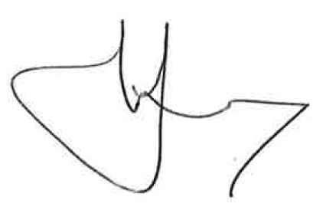
Dr Nigel Wells
Clinical Chair

