**York MASH: Safeguarding Children Together Campaign**

**Monday 1st June 2020 – Friday 5th June 2020**

**Campaign Briefing for Partners**

**What is the Multi-Agency Safeguarding Hub (MASH) in York?**

The Multi-Agency Safeguarding Hub (MASH) in York replaced the Children’s Front Door Service in July 2019. The MASH is a multi-agency team made up of representatives from a range of services, including Social Care, Early Help, Police and local Health Professionals. It is a single point of contact for all concerns about children. This new partnership approach will make it easier to support children, young people and their families to get the right level of support as quickly as possible.

**What is MASH Awareness Week?**

Monday 1st June – Friday 5th June will see the virtual launch of the MASH. The awareness campaign aims to highlight the work of the MASH in York, [the new multi-agency level of needs document (threshold document), the multi-agency referral form and the multi-agency response form.](https://www.saferchildrenyork.org.uk/concerned-about-a-child-or-young-person.htm)

The City of York Safeguarding Partnership (CYSCP) has worked very hard over the past year to develop the MASH and its processes. We think that it is important to highlight this work and therefore have created a series of key messages which can be shared across the partnerships to raise awareness of the MASH and its work.

We hope that by the end of the week professionals, wider partners and members of the public will have a better understanding of the role of the MASH, that professionals know which multi-agency guidance can be used when supporting families and how to make a referral if they are concerned about a child or young person.

We have developed a campaign brand: ***York MASH: Safeguarding Children Together*** for our virtual launch with a series of hashtags that can be used for social media, these include:

* #safeguardingchildrenyork
* #safeguardingchildrentogether
* #helpustohelpthem
* #YorkMASH
* #earlyhelpYork

**What Can You and Your Organisation Do?**

* Post MASH Awareness Week content on your social media accounts (suggested content overleaf)
* Follow CYSCP ([@YorkSCP](https://twitter.com/YorkSCP)) on Twitter and retweet their social media posts
* To share MASH Awareness Week posts on your social media accounts and get messages out across your networks
* Encourage colleagues to share this briefing and asking them to join you in supporting the MASH Awareness Week campaign

**Need More Info?**

For more information about the MASH awareness week campaign in the City of York or to discuss in more detail how you and your organisation can get involved, please contact CYSCP: [cyscp@york.gov.uk](mailto:cyscp@york.gov.uk)

Thank you in anticipation of your support for the June 2020 MASH Awareness Week Campaign.

**Ideas for Social Media**

Look out for our posts on the [CYSCP](https://twitter.com/YorkSCP) Twitter feed and re-tweet/share them to your followers. In addition, feel free to use the pre-populated messages below:

**Members of the public**

* Are you concerned about a child? Contact #YorkMASH on 01904 551900 or email [mash@york.gov.uk](mailto:mash@york.gov.uk). Further information can be found on the CYSCP website: <https://www.saferchildrenyork.org.uk/concerned-about-a-child-or-young-person.htm> #helpustohelpthem
* Did you know we’ve got a safeguarding hub which you can contact about any concerns or worries that you have about a child or young person? You can contact them on 01904 551900 or email [mash@york.gov.uk](mailto:mash@york.gov.uk). Further information can be found here: <https://www.saferchildrenyork.org.uk/concerned-about-a-child-or-young-person.htm> #helpustohelpthem.
* Are you concerned about a child? Call Multi-agency Safeguarding Hub (MASH) on 01904 551900. If you think a child is in immediate danger, call the police on 999. Further information can be found here: <https://www.saferchildrenyork.org.uk/concerned-about-a-child-or-young-person.htm> #helpustohelpthem
* When schools, colleges and childcare settings are not open to all, this may mean some children and young people are more isolated and vulnerable. To find out about support available, get in touch on 01904 551900 or [earlyhelp@york.gov.uk](mailto:earlyhelp@york.gov.uk) #earlyhelpYork #helpustohelpthem.
* This can be a stressful and uncertain time for some families. Reach out to find out about support available, 01904 551900 or [earlyhelp@york.gov.uk](mailto:earlyhelp@york.gov.uk) #earlyhelpYork #helpustohelpthem.
* Sometimes children and families need some extra support. Early help brings together people from the right services who can work with you and your family to help make things better. To find out about support available, get in touch on 01904 551900 or [earlyhelp@york.gov.uk](mailto:earlyhelp@york.gov.uk) #earlyhelpYork #helpustohelpthem.

**Professionals**

* The Children’s Front Door email has now changed to [MASH@york.gov.uk](mailto:MASH@york.gov.uk) but the phone number stays the same: 01904 551900 #safeguardingchildrenyork #safeguardingchildrentogether

<https://www.saferchildrenyork.org.uk/concerned-about-a-child-or-young-person.htm>

* The multi-agency Threshold Document, MASH Referral Form and Referral Response Form have all been updated and can be found at: <https://www.saferchildrenyork.org.uk/concerned-about-a-child-or-young-person.htm> #safeguardingchildrenyork #YorkMASH
* The multi-agency safeguarding hub is the single point of access for all concerns about a child and has replaced the Children’s Front Door. Call on 01904 551900 or email [MASH@york.gov.uk](mailto:MASH@york.gov.uk). Further information can be found at :<https://www.saferchildrenyork.org.uk/concerned-about-a-child-or-young-person.htm> #safeguardingchildrentogether
* The CYSCP has revised the multi-agency threshold guidance. This framework can be used for assessing and responding to the needs and risks of children. #safeguardingchildrenyork #safeguardingchildrentogether

It can be found at: <https://www.saferchildrenyork.org.uk/concerned-about-a-child-or-young-person.htm>

(Use images below with the text above)

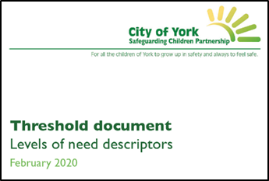 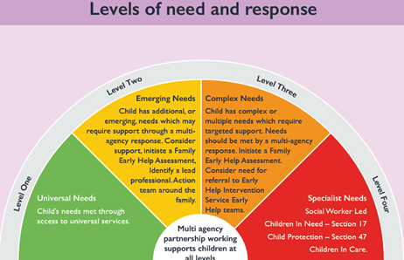

* Did you know that the MASH Referral Form has been updated? Link to referral form

It can also be found at: <https://www.saferchildrenyork.org.uk/concerned-about-a-child-or-young-person.htm>

#safeguardingchildrenyork #YorkMASH #safeguardingchildrentogether

(Use image below with the text above)

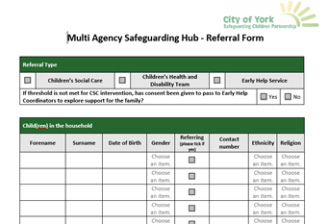

* Have you submitted a MASH Referral? You should receive a Referral Response from the MASH Team. More details can be found on the CYSCP website**:** [**https://www.saferchildrenyork.org.uk/concerned-about-a-child-or-young-person.htm**](https://www.saferchildrenyork.org.uk/concerned-about-a-child-or-young-person.htm)#safeguardingchildrenyork #safeguardingchildrentogether
* Partnership working means that, with your help, we can support more families. Get in touch on 01904 551900 or [earlyhelp@york.gov.uk](mailto:earlyhelp@york.gov.uk) #safeguardingchildrenyork #safeguardingchildrentogether #earlyhelpYork #YorkMASH
* Although we can’t currently deliver our early help training, we can provide remote advice and guidance to professionals about early help. Get in touch on 01904 551900 or [earlyhelp@york.gov.uk](mailto:earlyhelp@york.gov.uk) #safeguardingchildrenyork #safeguardingchildrentogether #earlyhelpYork #YorkMASH
* Are you supporting a family that may benefit from a Family Early Help Assessment? We can provide advice, guidance and tools to support you with this. Get in touch on 01904 551900 or [earlyhelp@york.gov.uk](mailto:earlyhelp@york.gov.uk) families #safeguardingchildrenyork #safeguardingchildrentogether #earlyhelpYork #YorkMASH
* Early help is all about providing children and families with the right help at the right time. If you notice a family in need of support, get in touch on 01904 551900 or [earlyhelp@york.gov.uk](mailto:earlyhelp@york.gov.uk) #safeguardingchildrenyork #safeguardingchildrentogether #earlyhelpYork #YorkMASH

**Email Banner (to use if you would like to)**



**York MASH: Safeguarding Children Together Virtual Campaign 1st June-5th June**

**The CYSCP are launching the new multi-agency Threshold document, the Referral Form and the Referral Response Form. For further information, go to the CYSCP website:** [**https://www.saferchildrenyork.org.uk/concerned-about-a-child-or-young-person.htm**](https://www.saferchildrenyork.org.uk/concerned-about-a-child-or-young-person.htm)

**Did you know that the MASH has replaced the Children’s Front Door? It’s a multi-agency team made up of representatives from a range of services, including Social Care, Early Help, Police and Health Professionals and is a single point of contact for all concerns about children. Contact the MASH team on 01904 551900 or email:** [**mash@york.gov.uk**](mailto:mash@york.gov.uk)**. If you would like to contact the Early Help Team call 01904 551900 or email:** [**earlyhelp@york.gov.uk**](mailto:earlyhelp@york.gov.uk)

**Please don’t forget to use the campaign hashtags on your posts:**

* #safeguardingchildrenyork
* #safeguardingchildrentogether
* #helpustohelpthem
* #YorkMASH
* #earlyhelpYork