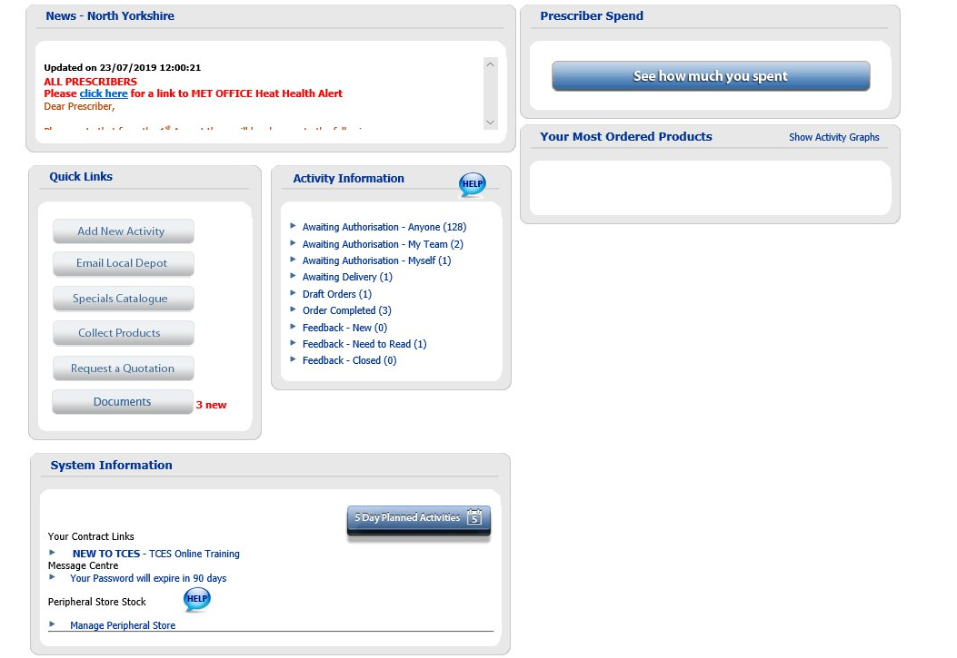

- From the home page on TCES select “Manage Peripheral Store”
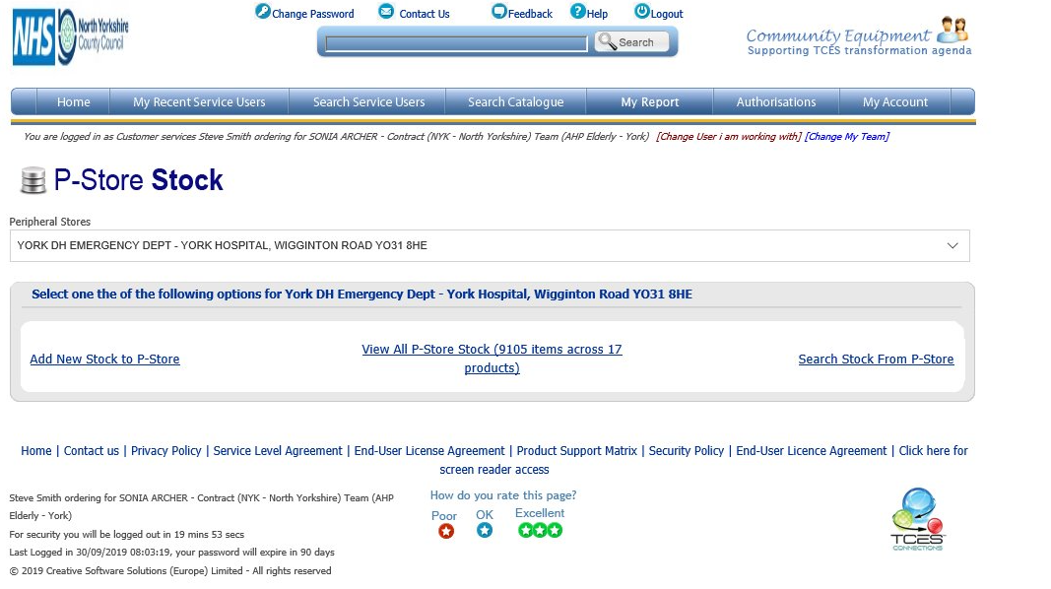
- Select the correct store from the “Peripheral Stores” drop down list
- Select “View All P-Store Stock”

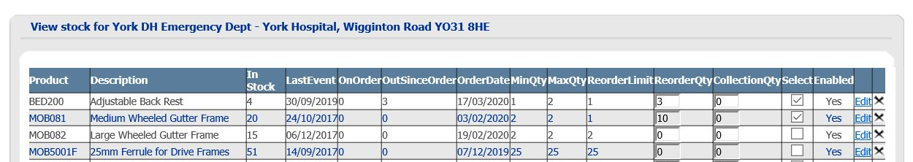
- Select “Reorder Qty” on first item to be ordered and enter the quantity to be ordered the click on the “Select” box. Complete for all items required
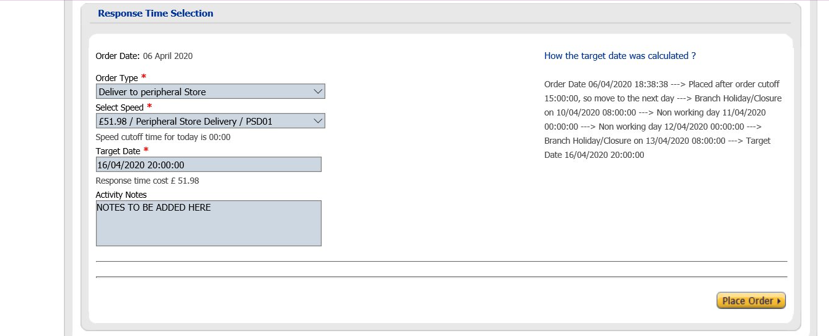

- From “Order Type” choose “Deliver to peripheral Store”
Select speed for delivery(currently only one)
Target date (self populates)
Add any “Activity Notes”
Click on “Place Order

