DOWNLOADING EMIS Web RSS REFERRAL LETTERS
(for importing into EMIS Web)

EMIS WEB - Template Download Instructions

- On the Vale of York website, click on the link to take you to the relevant letter template - the window which opens will resemble this:
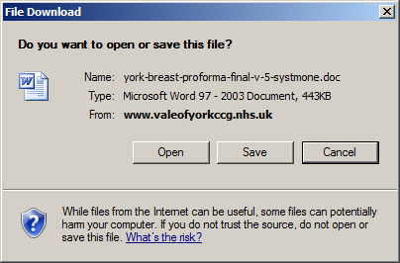
- Click on Save
- Save the file to a suitable location (ready for importing), you will see the file name is correct, click Save
- The file will save and the following window will appear:
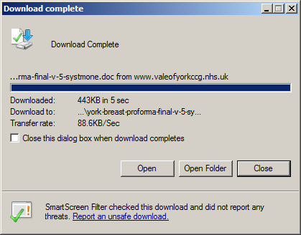
- Click on Close
EMIS WEB - Importing a template Instructions

- Navigate to the Word letter template section of EmisWeb via
  - EMIS menu
  - Configuration
  - Template Manager
  - Document Templates Tab

- Select the folder you want the template to be imported to and: ‘Import > Document’
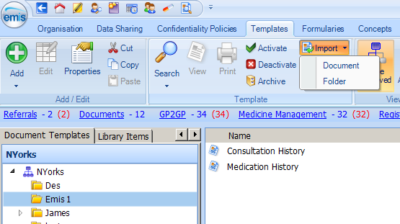

- Locate and Select the relevant template from the ‘Select Document’ window.

- The template should now be available for your use.

