DOWNLOADING SYSTMONE RSS REFERRAL LETTERS
(for importing into systmone – INTEGRATED WORD VERSION)

SystmOne - Integrated Word Version – Template Download Instructions

- On the Vale of York website, click on the link to take you to the relevant letter template - the webpage which opens will resemble this:
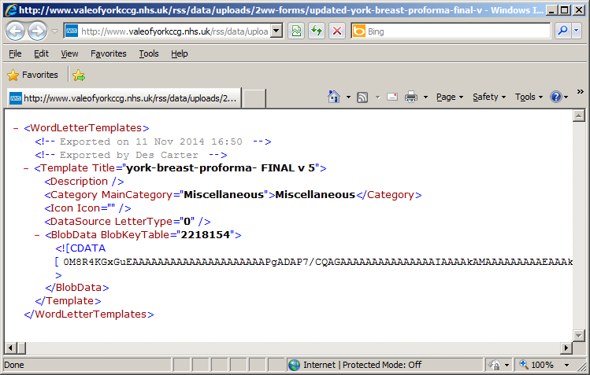
- Click on the File menu (top left corner) and select Save As… - the following window will appear:
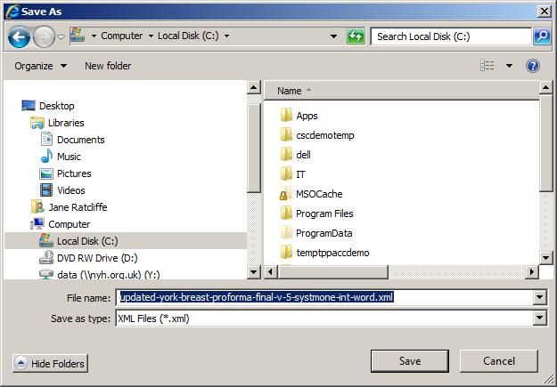
- Select a suitable location to place the template (ready for importing) - you will see the file name is correct, click on Save
SystmOne – Integrated Word Version - Importing a Template Instructions

- Navigate to the Word letter template section of SystmOne via
  - Setup
  - Referrals & Letters
  - *New* Word Letter Templates

- Click on the Import Templates button
- Locate and Select the relevant template on the ‘Import Templates’ window:
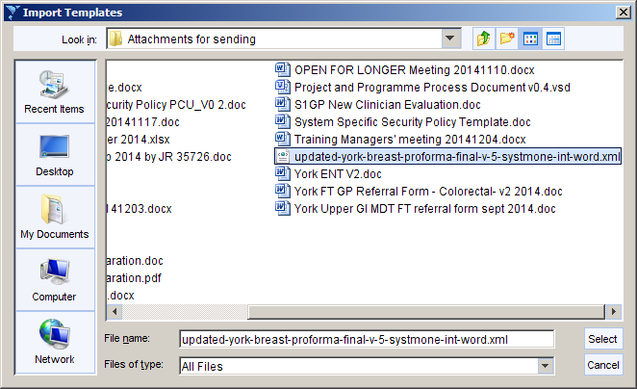
The template will be uploaded into SystmOne
You should then change the data source for the template in the following way:
- Right-click on the template and select Amend Document
- On the SystmOne Mail Merge tab select Select Data Source – the following window appears:
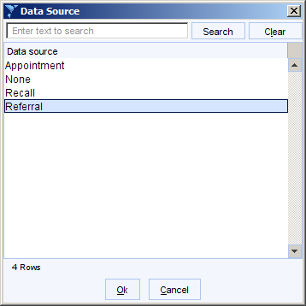
- On the Data Source window, select Referral and click Ok
- Save the template and then close Word

