DOWNLOADING SYSTMONE RSS REFERRAL LETTERS
(for importing into systmone – NON-INTEGRATED WORD VERSION)

SystmOne - Non-integrated Word Version – Template Download Instructions

- On the Vale of York website, click on the link to take you to the relevant letter template - the window which opens will resemble this:
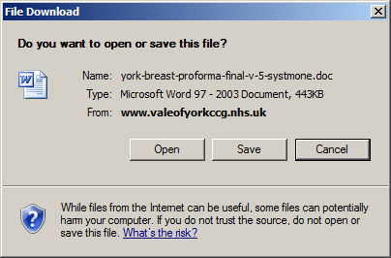
- Click on Save
- Save the file to a suitable location (ready for importing), you will see the file name is correct, click Save
- The file will save and the following window will appear:
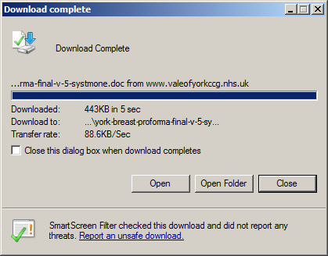
- Click on Close
SystmOne – Non-Integrated Word Version - Importing a template Instructions

- Navigate to the Word letter template section of SystmOne via
  - Setup
  - Referrals & Letters
  - *New* Word Letter Templates

- Click on the New Template button – the following window appears:
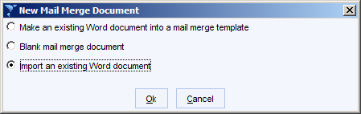
- Click on Import an existing Word document and click on Ok
- Locate and Select the relevant template from the ‘Select Document’ window:

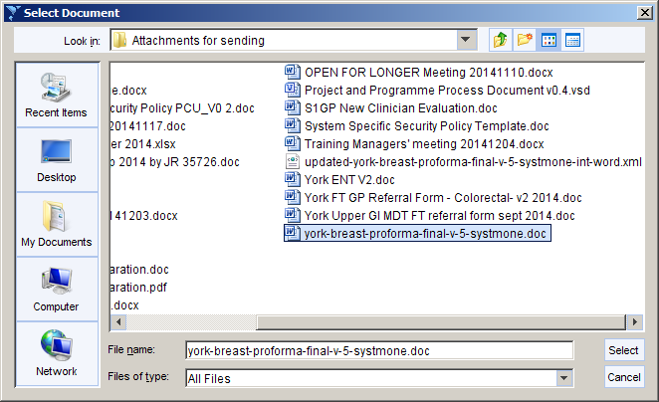

- On the ‘Word Letter Template’ window change the name and category (if you wish) to suit the way your practice works, click Ok
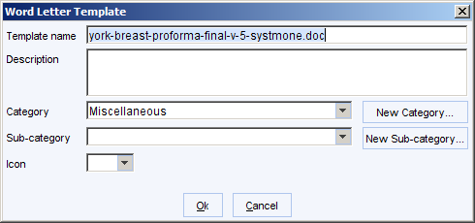

- The template should now be available for your use.

